 | EPIET/EUPHEM  Case Study | 



Childhood Vaccination coverage
survey in Greece, 2006

Athens, Greece

20-25 June 2016

Version: Short version 2016
Case study, June 2010
Authors: Kostas Danis, Dimitris Papamichail, Takis Panagiotopoulos

Based on a survey conducted by Takis Panagiotopoulos, Kostas Danis, Theano Geargakopoulou, Dora Stavrou and Dimitris Lagas in 2006.

Short version: Shortened and adapted for the EPIET/EUPHEM Rapid Assessment & survey methods module, 2014
Table of contents

Guide to the case study 5
Glossary 6
Brief description of case study 7
Introduction 8
Session 1 – Sampling 9
Task 1.1–Sampling strategy 9
Task 1.2–Use stratification (optional) 15
Task 1.3–Select a simple random sample (generate random numbers) (optional) 16
Task 1.4–Select a systematic sample (optional) 19
Task 1.5– Select a sample with probability proportional to size (optional) 20
Task 1.6– Cluster sampling (optional) 24
Session 2 – Sample size calculation 26
Task 2.1– Sample size calculation for a single proportion 26
Task 2.2– Sample size calculation for a single proportion using the design effect 30
Task 2.3– Sample size calculation using STATA 33
Session 3 – From analysis plan to data collection 36
Task 3.1– From analysis plan to data collection 36
Session 4 – Descriptive analysis 39
Task 4.1– Check if the sample is representative of the target population 39
Task 4.2– Response rate and differences between respondents and non-respondents 40
Task 4.3– Calculate sampling weights 42
Task 4.4– Calculate weighted proportions 44
Task 4.5– Estimate vaccination coverage 46
Session 5 – Predictors of vaccination coverage (optional) …………………………………………... 55
Task 5.1– Describe parental characteristics, beliefs towards vaccination 55
Task 5.2– Identify unadjusted determinants of vaccination coverage 60
Session 6 – Multivariable analysis (optional) 67
Task 6.1– Logistic regression 67
Task 6.2– Binomial regression 72
Conclusions 75
References 75
Annex 1: School registry extraction form 76
Annex 2: Vaccination Beliefs Questionnaire 78
Annex 3: Vaccination Abstraction Form 83
Annex 4: Fieldworker’s check-list of actions 87
Annex 5: Description of “school” database 89
Annex 6: Description of “vaccine” database 90
Annex 7: Description of “quest” database 92

Guide to the case study
The case study is designed for use with STATA version 10.
Nomenclature:

vaccine Name of dataset or file currently open
dtp1 Variable name
case=1 Text to be typed as shown

All files necessary for completing a session are placed in the corresponding session folder. There should be no need to copy files from other session folders, unless you use your own data files. The datasets have been modified so that no person identification is possible. All datasets have been simplified for the purpose of this case study.

Pre-requisites for participants
Participants should have some prior experience in data analysis and should be familiar with using STATA.

Glossary
BCG: Bacillus Calmette-Guérin
DTP: Diphtheria-Tetanus-Pertusis vaccine
DTaP: Diphtheria-acellular Tetanus-Pertusis vaccine
dt: reduced diphtheria toxoid-Tetanus toxoid

Hib: Haemophilus Influenzae type b
IPV: Inactivated Poliomyelitis Vaccine
MMR: Measles Mumps Rubella vaccine
OPV: Oral Poliomyelitis Vaccine
HepB: Hepatitis B
HepA: Hepatitis A
MCV: Meningococcal Conjugate Vaccine
Men C: Meningitis C
PCV7: Pneumococcal Heptavalent
PR: Prevalence Ratio
RR: Risk ratio/Rate ratio
OR: Odds Ratio

Brief description of case study
The case study is built around a national survey that used stratified cluster sampling to estimate the vaccination coverage of six year-old children and to identify predicting factors of complete and timely vaccination status. Teaching methods will include presentations, interactive exercises and exercises using computers.

Objectives of the case study
The aim of this case study is to equip participants with the tools to design and conduct a cross-sectional study to estimate vaccination coverage and analyse data from a cross-sectional survey. At the end of the course, participants should be able to:
1) Epidemiological skills
- Select the appropriate method to estimate vaccination coverage
- Understand the principles of basic sampling methods, including stratification and cluster sampling
- Select an appropriate sampling scheme
- Calculate the required sample size
- Identify methods of data collection to estimate vaccination coverage
- Interpret the results of the various analyses
- Communicate findings

2) Computer skills
- Perform descriptive analysis by calculating weighted proportions
- Conduct an analytical study using a cross-sectional survey with a stratified cluster sampling design

Sessions
This case study consists of the following 6 sessions:
- Session 1: Sampling
- Session 2: Sample size calculation
- Session 3: From analysis plan to data collection
- Session 4: Descriptive statistics with weighted proportions
- Session 5: Analysis to associations with having a fully vaccinated child

Duration of the case study: 7-9 hours (additional 3-4 hours for the optional sessions)

Introduction
Vaccine-preventable diseases are still a public health burden worldwide, largely due to suboptimal vaccination coverage, and constitute an important component of the health care debate in many countries. To improve vaccination coverage and reach high immunisation levels, the reasons for inadequate vaccinations need to be identified and addressed.

Vaccination in Greece
In Greece, vaccines included in the National Vaccination Programme (NVP) (Box 1) are provided free of charge to all residents (including immigrants) in primary health care centres or health insurance clinics. Childhood vaccination coverage is not monitored routinely. Several ad-hoc studies have been conducted occasionally at local level using non-representative samples. Most of the current knowledge on immunisation uptake is based on two national population-based surveys conducted in 1997 and in 2001 using representative samples of children attending the first year of Greek Grammar school (children born in 1991) and of two-year olds (children born in 1997), respectively. Results of those surveys showed high vaccination coverage [93.5% and 98.9% for the 3rd dose of diphtheria-tetanus toxoid and pertusis (DTP) vaccine; and 89.1% and 93.7% for the 1st dose of measles-mumps-rubella (MMR) vaccine in 1997 and 2001, respectively]. However, an outbreak of measles in 2006 revealed low coverage among the Roma minority (1% of the population) and immigrants (8% of the population) who accounted for 55% and 15% of all cases, respectively.

Box 1- Recommended childhood vaccination schedule according to the National Vaccination Programme (NVP) at the time of the study in Greece.
Recommended age | DTaP*† | Hib*† | IPV*† | MMR*† | HepB*† | MCV*† | PCV7*† | Var*† | BCG* | dT*
2 months | Yes | Yes | Yes |  | Yes | Yes | Yes
4 months | Yes | Yes | Yes |  | Yes | Yes | Yes
6 months | Yes | Yes |  |  |  |  | Yes
6-18 months |  |  | Yes |  | Yes
12-15 months |  | Yes |  | Yes |  |  | Yes
12-18 months |  |  |  |  |  |  |  | Yes
15-18 months | Yes |  |  |  |  | Yes
4-6 years | Yes |  | Yes | Yes
6 years |  |  |  |  |  |  |  |  | Yes
11-18 years |  |  |  |  |  |  |  |  |  | Yes
13-18 years |  |  |  |  |  |  |  | Yes
>18 years |  |  |  |  |  |  |  |  |  | Yes
* DTaP= Diphtheria-acellular Tetanus-Pertusis (DTP); Hib= Haemophilus Influenzae type b (HiB); IPV= Inactivated Polio Vaccine; MMR= Measles-Mumps-Rubella; HepB=Hepatitis B; MCV= Meningococcal Conjugate Vaccine; PCV7= Pneumococcal Heptavalent; BCG=Bacillus Calmette-Guérin; dT= reduced diphtheria toxoid-Tetanus toxoid
†DTP, IPV and MMR were introduced in the NVP before 1990; HepB and Hib in 1998 and 2002, respectively; and PCV-7,Var and MNC in 2006, although MNC was available in the pharmacies since 2001

Scenario
You work at the national public health institute and you are asked to provide data on vaccination coverage of children in Greece and identify the potential reasons for low vaccination uptake.

Session 1 – Sampling
Session overview
This session focuses on how to select a representative sample from a specified population, using basic and more complex sampling methods.
By the end of this session, participants should be able to:
- understand the principles of basic sampling methods
- identify different sampling design options for a vaccination coverage survey
- understand the meaning of target and sample populations, primary and final sampling units, and sampling frame
- understand complex designs, especially cluster sampling and stratification
- identify the necessary number of sampling units in different strata in a survey
- draw a simple random and a systematic sample
- generate random numbers using STATA and EXCEL
- draw a simple random sample with probability proportional to size

This session consists of 6 Tasks:
- Task 1.1–Sampling strategy
- Task 1.2–Use stratification (optional)
- Task 1.3–Select a simple random sample (generate random numbers) (optional)
- Task 1.4–Select a systematic sample (optional)
- Task 1.5–Select a sample with probability proportional to size (optional)
- Task 1.6–Cluster sampling (optional)
Tasks 1.2 -1.6 are optional.

To complete the work in this session you will need:
- EXCEL software
- STATA software (version 10 or later)
- An Excel file (“session_2_sampling”) that is provided in session 1 folder (optional).

Task 1.1–Sampling strategy
The aim of the study was to estimate the vaccination coverage among 6-year-old children in Greece and identify reasons for incomplete vaccination status.

The specific objectives were to:
- estimate the vaccination coverage of 6-year-old children for all vaccines included in the National Vaccination Programme:
i) overall in Greece,
ii) by geographical region (6 regions, urban and rural areas),
iii) by minority group (i.e. immigrants, Greek Muslims, Greek Roma)
- examine the associations between socioeconomic status, parental beliefs and attitudes towards immunisation, and perceptions of barriers to vaccination on complete vaccination status among 6-year old children

Q1.1. What sampling frames might be available? What are some necessary prerequisites for using them?

You may consider the following sampling frames:
- Resident registries from local authorities (They need to be relatively complete and updated),
- Patient registries from primary care services (They need to be available and relatively complete),
- Child vaccination registries (if available),
- Telephone directories to identify families (They have to be exhaustive. There are usually multiple operators and networks)
- Social security registry of parents (information on children might not be available)
- School registries (In this case, a large proportion of the population should attend school).

In this survey the researchers decided to take a sample of 1st grade school children.To assess whether this study population is appropriate, it would be necessary to have information on:
- whether attendance in primary school is compulsory
- provision for children with handicap or other health problems and for children living in special social circumstances,
- possible educational institutions for 6 year-old children other than “primary schools”,
- existence of special education, private schools, minority schools, religious schools etc.
- school attendance of the general childhood population as well as of children belonging to special groups (e.g. immigrants, Roma etc.).

A full list of school children was impossible to obtain. Nevertheless, it was feasible to get a list of all schools in the country, with number of 1st grade classes in each school.

Q1.2. What options of sampling schemes would you consider? What are the advantages and disadvantages of each one?

The following options of sampling schemes should be considered:
Sampling of children (final sampling units)
- 1st stage: cluster sampling with schools as clusters of children. Advantage: simplicity. Disadvantage: large clusters if no further sampling in 2nd stage is used.
- 1st stage: cluster sampling with schools-classes as clusters of children. Advantage: smaller clusters than previous option, simple enough to organise.
- 2nd stage: all children in school or school-class. Advantage: simplicity.
- 2nd stage: sample of children in schools or school-classes selected in 1st stage. Advantage: more efficient design.
Sampling of school-classes or schools (clusters, primary sampling units)
- Simple random sample of school classes or schools. Advantage: a/ theoretically correct, b/ simple analysis. Disadvantage: a/ wide distribution across the country with practical difficulties, b/ adequate sample size in each region not ensured (see objectives).
- Systematic sample of school classes or schools. No particular advantage compared to simple random sampling.
- Stratification by region. Advantage: a/ more efficient design (the more the regions are heterogeneous between and homogeneous within themselves in terms of vaccination coverage, the more efficient the design, i.e. the narrower the confidence intervals), b/ adequate sample size in each region is ensured.
- Stratification by region and by urban/rural area. Advantage: same as a/ above.

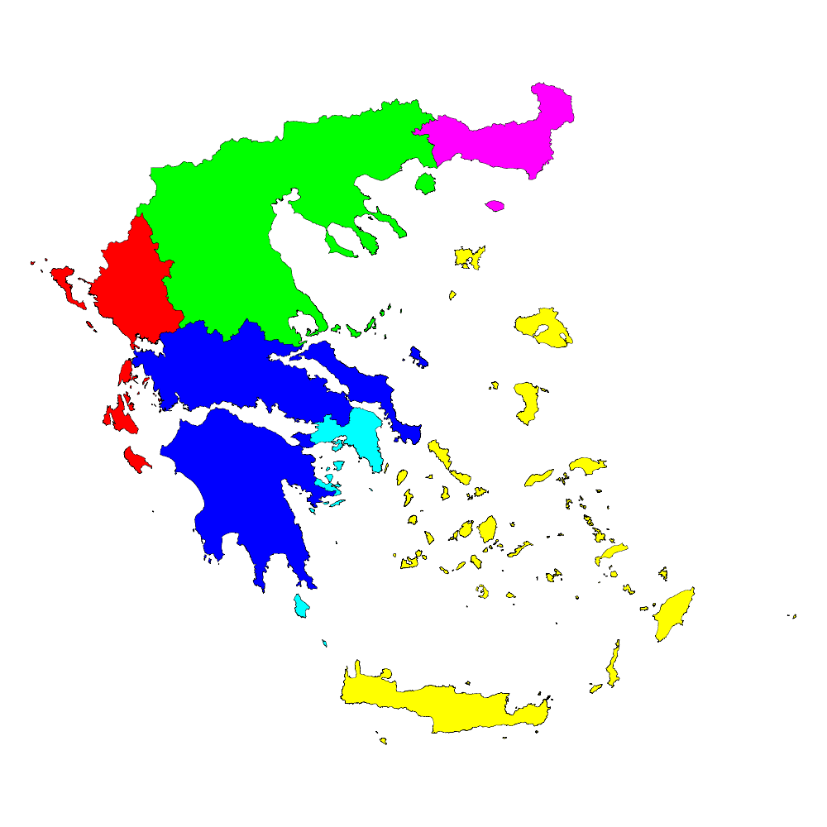
5
6
4
3
2
1
Figure 1.1. Map of Greece with the regions used in stratification.
Note: (1) Thraki; (2) Macedonia-Thessalia; (3) Ipeiros-Ionian Islands; (4) Peloponissos-Sterea; (5) Attiki; (6) Crete-Aegean Islands.

The researchers decided to use the following sampling strategy: stratified cluster sampling of first-grade school children, using school classes as clusters and stratification by region (see map) and urban/rural area; approximately equal sample size was used in each region, and within each region sample size in urban/rural areas was proportional to size; all children in school-classes were selected.

Q1.3. Explain in plain language the sampling strategy chosen by the researchers and describe the different steps of sampling.

A national sample of first grade school children was selected using the following sampling strategy:
a/ The country was divided into six geographical region (Figure 1.1).
b/ Each region, apart from the capital region (Attica), was further subdivided into urban and rural areas, to create 11 strata. According to the National Statistical Authority of Greece, urban areas are defined as towns/cities with 2,000 population or more, while rural areas as villages/towns with less than 2,000 population
c/ A sample of approximately equal size was taken in each region
d/ Within each region, samples were selected with probability proportional to the size of urban and rural areas
e/ School classes were used as clusters of children
f/ A simple random sample of school classes was selected in each stratum
g/ All children of selected school classes (clusters) were selected in the final sample.

Q1.4. In this sampling design:
a/ what is the target population?
b/ what is the study population?
c/ what are the primary sampling units?
d/ what are the final sampling units?
e/ what sampling frame could be used?

a/ Target population: 6-year-old children in Greece
b/ Study population: children attending first grade of primary school
c/ Primary sampling units: school classes
d/ Final sampling units: children
e/ Sampling frame that could be used: list of all schools in each stratum, with number of first grade classes in each school.

Q1.5. “Samples of approximately equal size were selected in each region”. Why do you think this was done? What complexity does it introduce?

The researchers had set as their objective to estimate vaccination coverage by geographical region. Therefore, the sample size would have to be adequate in each and every region in order to have estimates of acceptable precision. As a consequence, the researchers chose to get samples of equal size in each region. (In fact, they aimed at a somewhat higher precision for the region of Attiki, and therefore the sample size for this region was somewhat larger).
As the population of each region is different, opting for equal sample size in each region leads to different sampling fractions for each region. This means that weighting should be used in the analysis (for national level results) to take account of the different sampling fractions of the regions. This increases the complexity of the analysis.

Task 1.2–Use stratification (optional)
Stratified sampling is used when the population consists of distinct subgroups (strata), which differ with respect to the feature under study. In this study, researchers expected urban and rural areas in each region to be different in terms of vaccination coverage. Therefore, the same proportion of clusters (school classes) was taken from each stratum within a region to ensure that they were all adequately represented.
- Within each region, select clusters (school classes) with probability proportional to the size of urban and rural areas. Calculate the number of school classes to be selected in each stratum and complete Table 1.2. Suppose you decided to include in the sample 50 school classes from each region. Assume that all school classes have an equal number of students. You may use the Excel file “session_2_sampling” Worksheet “Table 1.2”.
Table 1.2 shows the population of children aged 5-9 years of each region in Greece by urban/rural area.
Table 1.2. Number of children aged 5-9 years in Greece by region and urban/rural area.
 | Number |  |  | Proportion (%) |  |  | Number of school classes in sample
 | Urban | Rural | Total
Thraki  Macedonia-Thessalia  Ipeiros-Ionian Islands  Peloponissos-Sterea  Attiki  Crete-Aegean Islands | 11,624  116,322  11,446  55,770  174,493  36,374 | 6,884  47,101  15,449  44,132  1,667  24,752 | 18,508  163,423  26,895  99,902  176,160  61,126
TOTAL GREECE | 406,029 | 139,985 | 546,014

Help, Task 1.2
The completed version of Table 1.2 should look like the following:
Table 1.2. Population children aged 5-9 years in Greece by region and urban/rural area with proportion of population and number of school classes in sample for each stratum used in the survey.
 | Number |  |  | Proportion (%) |  |  | Number of school classes in sample
 | Urban | Rural | Total | Urban | Rural | Total | Urban | Rural | Total
Thraki  Macedonia-Thessalia  Ipeiros-Ionian Islands  Peloponissos-Sterea  Attiki  Crete-Aegean Islands | 11,624  116,322  11,446  55,770  174,493  36,374 | 6,884  47,101  15,449  44,132  1,667  24,752 | 18,508  163,423  26,895  99,902  176,160  61,126 | 62.8  71.2  42.6  55.8  99.1  59.5 | 37.2  28.8  57.4  44.2  0.9  40.5 | 100  100  100  100  100  100 | 31  36  21  28  50  30 | 19  14  29  22  0  20 | 50  50  50  50  50  50
TOTAL GREECE | 406,029 | 139,985 | 546,014

Task 1.3–Select a simple random sample (generate random numbers) (optional)
Table 1.3 is part of the sampling frame for the stratum “rural areas of the region of Peloponissos-Sterea”, where all schools have only one first grade school-class.
Q1.6. What would be the necessary steps to select a simple random sample of 22 school classes from the sampling frame (Table 1.3)? What is the sampling fraction in this case?

Steps for drawing a simple random sample:
- Select 22 random numbers from the 102 school classes included in the sampling frame (Table 1.3), using a computer programme (EXCEL and STATA)
- Sort the selected numbers by order, list them, and in Table 1.3 mark the selected school classes

Sampling fraction=22/102
=22%

- Generate 22 random numbers using STATA and EXCEL.
- List the selected numbers and mark the selected school classes in Table 1.3
Table 1.3. List of school classes in rural areas of the region of Peloponissos-Sterea.
  ID | School Code
  1 | ACH-013
  2 | ACH-014
  3 | ACH-017
  4 | ACH-027
  5 | ACH-036
  6 | ACH-037
  7 | ACH-040
  8 | ACH-055
  9 | ACH-056
  10 | ACH-060
  11 | ACH-068
  12 | ACH-093
  13 | ACH-096
  14 | ACH-105
  15 | ACH-106
  16 | ACH-107
  17 | ACH-110
  18 | ACH-115
  19 | ACH-116
  20 | ACH-118
  21 | ACH-119
  22 | ACH-123
  23 | ACH-128
  24 | ACH-129
  25 | ACH-137
  26 | ACH-138
  27 | ACH-150
  28 | ACH-159
  29 | ACH-162
  30 | ACH-164
  31 | ACH-166
  32 | ACH-173
  33 | ACH-175
  34 | ACH-177
  35 | ACH-179
  36 | ACH-184
  37 | ACH-185
  38 | ACH-187
  39 | ACH-189
  40 | ACH-191
  41 | ACH-195
  42 | ACH-196
  43 | ACH-197
  44 | ACH-200
  45 | ACH-206
  46 | ACH-209
  47 | ACH-211
  48 | ACH-215
  49 | ACH-216
  50 | ACH-223
  51 | ACH-227
  ID | School Code
  52 | ACH-230
  53 | ACH-265
  54 | ACH-270
  55 | ACH-275
  56 | ACH-276
  57 | ACH-282
  58 | ACH-290
  59 | ACH-291
  60 | ACH-294
  61 | ACH-327
  62 | ACH-330
  63 | ACH-336
  64 | ACH-338
  65 | ACH-346
  66 | ACH-351
  67 | ACH-353
  68 | ACH-359
  69 | ACH-364
  70 | ACH-368
  71 | ACH-372
  72 | ACH-375
  73 | ACH-376
  74 | ACH-406
  75 | ACH-430
  76 | ACH-519
  77 | ACH-573
  78 | ILIA-015
  79 | ILIA-016
  80 | ILIA-020
  81 | ILIA-021
  82 | ILIA-026
  83 | ILIA-028
  84 | ILIA-029
  85 | ILIA-030
  86 | ILIA-031
  87 | ILIA-032
  88 | ILIA-034
  89 | ILIA-036
  90 | ILIA-037
  91 | ILIA-040
  92 | ILIA-042
  93 | ILIA-043
  94 | ILIA-044
  95 | ILIA-045
  96 | ILIA-047
  97 | ILIA-048
  98 | ILIA-049
  99 | ILIA-051
  100 | ILIA-052
  101 | ILIA-053
  102 | ILIA-062

Help, Task 1.3
Generate 22 random numbers using STATA
- Launch STATA and use command line to write your commands.
- Before you select random numbers, create 102 observations (i.e. the total number of school classes in this stratum).
set obs 102
- Assign a random number to each observation and call it “rand” (variable name)
To select random numbers, use the STATA function ’uniform’.
gen rand=uniform()*102
list in 1/22
- To become familiar with the function, type:
help random_number_functions
- To generate random numbers over the interval [10,100), use
gen rand2= 10+(100-10)*runiform()
list in 1/22
- To generate random integers over [10,100], use
gen rand3= 10+int((100-10+1)*runiform())
list in 1/22

You should now have the 22 random numbers corresponding to the 22 school classes that you will include in your sample from this stratum.

Generate 22 random numbers using R
- Launch R and use the console to write your commands.
- To select 22 random numbers from 1 to102, use the R function “sample”.
rand_sample <- sample(1:102, 22, replace = F)

- To become familiar with the function, type:
?sample
- To generate 22 random numbers over the interval [10,100), use
rand_sample2 <- sample(10:100, 22, replace = F)

Generate 22 random numbers using EXCEL
- Start Excel.
- Use “Format” – “Cell” – “Number” to set number of decimal places required in the random numbers to be generated (in this case “0 decimal places” is appropriate).
- Use the command “=RAND()*N” for numbers from 1 to N (for other options, e.g. random numbers from A to B, see Help).
- Copy and “Paste special” – “Values” the selected numbers.
- Sort the random numbers by order (using “Data” – “Sort”).

Task 1.4–Select a systematic sample (optional)
Q1.7. What is the process for a systematic sample of 22 schools among 102 schools.

Q.1.8 What would be the advantages and disadvantages of using systematic sampling?
Help, Task 1.4
Process for drawing a systematic sample:
- Divide total sampling population (102 schools) by the sample size (102/22=7)
- Choose a random starting point (for 7 the starting point will be chosen randomly from 1 to 7). Select a random number from 1 to 7 using STATA (as above). In Table 1.3 mark the randomly selected first school in the sample.
- Select units (schools) at regular intervals (every 7th school). In Table 1.3 mark all the selected schools in the sample.
Advantages:
No special advantage of using systematic rather than simple random sampling in this case. Therefore, go for the original – simple random sampling! (A typical situation when systematic sample is necessary: list of sampling units not available, but they present regularly, e.g. patients in surgery.)
Disadvantages:
Bias can be introduced, if the sampling units are grouped in such a way that particular characteristics occur at regular intervals Therefore, the assumption made with systematic sampling is that there is no underlying pattern in the sampling frame.

Task 1.5– Select a sample with probability proportional to size (optional)
In this survey, school classes were used as primary sampling units, as the researchers assumed that all school classes had almost equal number of students. An alternative choice would be to get a sample of schools. However, the number of students clearly differed between schools.
Table 1.5 is part of the sampling frame for the stratum “Attiki” (urban areas only), which includes the number of school classes and students in each school.
- Select a sample of schools (not school classes) using Table 1.5 as a sampling frame.
- Follow all the necessary steps to select a simple random sample of 12 schools. Select schools without replacement. Suppose you selected the following random numbers: 68, 1149, 2310, 221, 2171, 899, 1991, 938, 1859, 884, 983, 461, 1177, 28, 1173, 867, 1629, 42. You can use the Excel file “session_1_sampling” Worksheet “Table 1.5” to make the necessary calculations.

Q.1.9 What does selection “without replacement” suggest?

Selection “without replacement” suggests that after selection, a school is NOT included in the draw and may not be selected again. Therefore, if a school is “selected” for a second or a third time, this is not taken into account.
Table 1.5. List of schools in the region of Attiki (urban areas) with number of school classes and students.
ID | School Code | School classes | Students
1 | ATT-680 | 1 | 22
2 | ATT-684 | 2 | 28
3 | ATT-685 | 1 | 25
4 | ATT-817 | 1 | 27
5 | ATT-819 | 4 | 88
6 | ATT-898 | 4 | 116
7 | ATT-899 | 2 | 52
8 | ATT-915 | 2 | 52
9 | ATT-923 | 3 | 27
10 | ATT-928 | 5 | 95
11 | ATT-930 | 1 | 18
12 | ATT-931 | 1 | 25
13 | ATT-936 | 1 | 21
14 | ATT-937 | 4 | 112
15 | ATT-938 | 4 | 96
16 | ATT-943 | 4 | 76
17 | ATT-944 | 2 | 40
18 | ATT-945 | 3 | 63
19 | ATT-946 | 1 | 16
20 | ATT-947 | 3 | 63
21 | ATT-953 | 1 | 20
22 | ATT-956 | 4 | 72
23 | ATT-966 | 5 | 105
24 | ATT-972 | 4 | 96
25 | ATT-974 | 3 | 81
26 | ATT-975 | 2 | 42
27 | ATT-084 | 3 | 54
28 | ATT-085 | 2 | 44
29 | ATT-086 | 2 | 52
30 | ATT-088 | 1 | 27
31 | ATT-094 | 2 | 52
32 | ATT-096 | 1 | 18
33 | ATT-097 | 3 | 66
34 | ATT-098 | 4 | 88
35 | ATT-103 | 5 | 100
36 | ATT-104 | 5 | 105
37 | ATT-105 | 2 | 30
38 | ATT-107 | 1 | 15
39 | ATT-109 | 1 | 25
40 | ATT-110 | 1 | 15
41 | ATT-114 | 3 | 72
42 | ATT-117 | 3 | 54
43 | ATT-120 | 2 | 42
44 | ATT-131 | 2 | 46
45 | ATT-133 | 4 | 40
46 | ATT-136 | 1 | 21
47 | ATT-138 | 4 | 88
48 | ATT-139 | 3 | 54
 | TOTAL | 123 | 2586
Help, Task 1.5
- You should select schools with probability proportional to size (PPS).
- Process for selecting a simple random sample with probability proportional to size:
- Calculate the cumulative number of students by school in the list of schools (total 2586 students).
- Select 12 random numbers (plus some more to accommodate for selection “without replacement”) between 1 and 2586 (the total number of pupils). The random numbers should be selected in the usual way (see Q1.7). In this case these are already provided.
- Find the schools which correspond to the selected random numbers using the cumulative numbers (see Table 1.5). Select schools “without replacement”. Use only the random numbers necessary to select 12 schools as required (in this example, ignore # 899, 983, 1177): this is legitimate as all numbers are selected at random independently.
- At the end, you should randomly select the same number of 1st grade students from each selected school to ensure that each child has the same inclusion probability (self-weight).

Below you will find the completed version of Table 1.5:
Table 1.5. List of schools in the region of Attiki (urban areas) with number of school classes, students, cumulative number of students and selected classes.
ID | School Code | School classes | Students | Cumulative N | Selected classes
1 | ATT-680 | 1 | 22 | 22
2 | ATT-684 | 2 | 28 | 50 | 28
3 | ATT-685 | 1 | 25 | 75 | 68
4 | ATT-817 | 1 | 27 | 102
5 | ATT-819 | 4 | 88 | 190
6 | ATT-898 | 4 | 116 | 306 | 221
7 | ATT-899 | 2 | 52 | 358
8 | ATT-915 | 2 | 52 | 410
9 | ATT-923 | 3 | 27 | 437
10 | ATT-928 | 5 | 95 | 532 | 461
11 | ATT-930 | 1 | 18 | 550
12 | ATT-931 | 1 | 25 | 575
13 | ATT-936 | 1 | 21 | 596
14 | ATT-937 | 4 | 112 | 708
15 | ATT-938 | 4 | 96 | 804
16 | ATT-943 | 4 | 76 | 880
17 | ATT-944 | 2 | 40 | 920 | 884 (899)
18 | ATT-945 | 3 | 63 | 983 | 938 (983)
19 | ATT-946 | 1 | 16 | 999
20 | ATT-947 | 3 | 63 | 1062
21 | ATT-953 | 1 | 20 | 1082
22 | ATT-956 | 4 | 72 | 1154 | 1149
23 | ATT-966 | 5 | 105 | 1259 | 1173 (1177)
24 | ATT-972 | 4 | 96 | 1355
25 | ATT-974 | 3 | 81 | 1436
26 | ATT-975 | 2 | 42 | 1478
27 | ATT-084 | 3 | 54 | 1532
28 | ATT-085 | 2 | 44 | 1576
29 | ATT-086 | 2 | 52 | 1628
30 | ATT-088 | 1 | 27 | 1655
31 | ATT-094 | 2 | 52 | 1707
32 | ATT-096 | 1 | 18 | 1725
33 | ATT-097 | 3 | 66 | 1791
34 | ATT-098 | 4 | 88 | 1879 | 1859
35 | ATT-103 | 5 | 100 | 1979
36 | ATT-104 | 5 | 105 | 2084 | 1991
37 | ATT-105 | 2 | 30 | 2114
38 | ATT-107 | 1 | 15 | 2129
39 | ATT-109 | 1 | 25 | 2154
40 | ATT-110 | 1 | 15 | 2169
41 | ATT-114 | 3 | 72 | 2241 | 2171
42 | ATT-117 | 3 | 54 | 2295
43 | ATT-120 | 2 | 42 | 2337 | 2310
44 | ATT-131 | 2 | 46 | 2383
45 | ATT-133 | 4 | 40 | 2423
46 | ATT-136 | 1 | 21 | 2444
47 | ATT-138 | 4 | 88 | 2532
48 | ATT-139 | 3 | 54 | 2586
 | TOTAL | 123 | 2586

Task 1.6– Cluster sampling (optional)
Cluster sampling and stratification was used in this survey.

Q.1.10. Describe the basic idea of cluster sampling and stratification. What are the effects of these elements on the precision of the estimates? Think of extreme situations to intuitively understand these effects.

1) Cluster sampling
a/ Basic idea: i) group sampling units (or, better, use “natural” grouping of sampling units; e.g. students grouped in school-classes or schools), ii) select a sample of these groups.
b/ Effect on precision: i) decrease in precision compared to simple random sampling (for the same sample size), (confidence intervals tend to be wider), ii) homogeneity between clusters and heterogeneity within clusters is an advantage: precision increased. [Extreme situation: all clusters are 100% homogeneous between them, e.g. there is exactly the same vaccination coverage in all school-classes → as if clusters were part of the same simple random sample.]
2) Stratification
a/ Basic idea: i) group sampling units (or, better, use “natural” grouping of sampling units; e.g. students, school-classes or schools grouped in regions), ii) select a sample in each group separately.
b/ Effect on precision: i) increase in precision compared to simple random sampling (for the same sample size), (confidence intervals tend to be narrower), ii) heterogeneity between strata and homogeneity within strata is an advantage: precision increased. [Extreme situation: all strata are 100% heterogeneous between themselves, e.g. extreme differences in vaccination coverage in different regions → as if strata are comprised of totally different populations → advantage in employing separate sampling procedures rather than mixing the populations.]
We will discuss these issues in more depth in the following session.

Session 2 – Sample size calculation
Session overview
One of the most important factors to consider in the design of a survey is the choice of an appropriate sample size. Studies that are too small may fail to detect important effects or obtain an imprecise estimate. Studies that are larger than necessary are a waste of time, money and other resources. In this session, you will perform all the necessary calculations to obtain the required sample size for a single proportion. In the first part, you will perform your own calculations using a calculator and subsequently you will do the same calculations using STATA.
A presentation on “Sample size calculation” should precede this session.

This session consists of 3 Tasks:
- Task 2.1– Sample size calculation for a single proportion
- Task 2.2– Sample size calculation for a single proportion using the design effect
- Task 2.3– Sample size calculation using STATA

To complete the work in this session you will need:
- a handheld calculator
- STATA software (version 10)
- The “sampclus.ado” file and sampclus help file for the sampclus downloadable STATA command. You may find these files in Session 3 folder.

Note that this case study covers only sample size calculations for a single proportion based on the precision of a study. It is not intended to cover sample size calculations based on the assessments of sample size or power for studies that compare proportions, means or incidence rates between two groups.

Task 2.1– Sample size calculation for a single proportion
You may remember that the formula used in calculating a confidence interval, assuming simple random sampling, is:

CI= p ± z · √[(p · (1-p)/n] (formula 2.1)
d

where: p is the estimated proportion in the sample
z represents the number of standard errors away from the mean of the sampling distribution (z=1.96 for 95% CI)
n is the sample size
d is the precision of the estimate or z·Standard Error (SE)

A more precise formula is the following:

CI= p ± z · √ [(p · (1-p)/n] · [1-(n/N)] (formula 2.2)
SE Finite population correction
where N is the total sampling population.

Note that this expression incorporates the finite population correction (fpc) [1-(n/N)]. If the population is very large relative to the sample (i.e. small sampling fraction), the fpc approximates 1 and can be reasonably omitted. If the entire population is included in the sample, the fpc becomes 0 and so does the standard error. As a rule of thumb, the fpc should not be ignored if the sampling fraction (n/N) exceeds 5%-10% or if the total sampling population is less than 10,000 people. In that case, if the fpc is not used in the formula, the confidence intervals will be wider and the sample size larger than necessary. Otherwise, the size of the total population from which the sample is drawn has little effect in practice, and may be ignored.

The first formula can be rearranged to give an expression for the calculation of the sample size:

n= [z² · p · (1-p)] / d² (formula 2.3)

OR

n=[(z² · p · (1-p) ·N ] / [d² · (N-1)+ z²· p(1-p)] (formula 2.4)
(with finite population correction)

Q 2.1.1 Based on the above, which parameters should you take into account for the calculation of a sample size for a single proportion, assuming simple random sampling?
The required sample size should be determined by focusing on the primary objective of the study (e.g. the estimation of the vaccination coverage among 6-year-old children in Greece in this survey). To calculate the number of participants required to achieve the objectives of the survey, you should specify the following:
- Expected frequency of the principal outcome measure (based on the main objective of the study) (e.g. expected vaccination coverage). The expected frequency may be obtained from previous surveys of similar subject matter. Note that the sample size will be largest when p=0.5 and it decreases slowly as the difference between p and 0.5 increases. Hence, if the expected frequency is unknown, choosing 0.5 for p will always provide enough observations, irrespective of the true population proportion.
- The desired precision of the study. To select the appropriate sample size it is necessary to decide how precise you would like your estimate (e.g. vaccination coverage) to be. The amount of “precision” (sampling error) is represented by the width of the confidence interval around your estimate. The narrower the confidence interval (CI), the greater the precision of the estimate, but the higher the number of subjects that you need to include in the study. It is therefore necessary to decide on the width of an acceptable confidence interval. Hence, you should specify to within how many percentage points of the population value your sample estimate should be. For example, if the expected vaccination coverage is 50%, you may wish your sample estimate to be within 1%, giving a confidence interval of 49% to 51%.
- The quantity z, that represents the number of standard errors away from the mean of the sampling distribution. For a level of significance of 5% (95% CI), z equals 1.960, whereas for significance levels of 10% (90% CI) or 1% (99% CI), z equals 1.645 or 2.576, respectively.

Previous vaccination coverage surveys in the country have shown that vaccination coverage exceeded 85% for most vaccines. As the country was divided into 6 regions for this study, each region was considered as a separate survey and calculations were performed for each one to give the sample size with a fixed precision. The researchers decided to estimate the vaccine coverage for each of the 6 regions of the country with sufficient precision of ± 4%. This way, the precision of the overall national estimate was somewhat better than that for any single region.
The following table presents the total number of pupils by region.

Table 2.1. Total number of pupils (recorded in the sampling frame) by region.
Region | Number of pupils  (sampling frame*)
Thraki  Macedonia-Thessalia  Ipeiros-Ionian islands  Peloponnisos-Sterea Ellada  Attiki  Kriti-Aegean islands  Greece (Total) | 4,201  31,045  5,055  17,741  30,586  12,218  100,846
*year 2005

Q 2.1.2 Taking into account the above information, calculate the required sample size in each region, assuming simple random sampling. Use formula 2.3 or 2.4 and a handheld calculator or the “display” command in STATA, which can be used as a substitute for a calculator.
Using formula 2.3 and replacing z=1.96, p=0.85 (85%) and d=0.04 (4%)

n= [z² · p · (1-p)] / d²

you should recruit n=306 children from each region to achieve the objectives of the study. However, for regions with a population size<10,000 (or a sampling fraction >10%, if known), the required sample size will be smaller, as you may see using formula 2.4 (n=285 for Thraki and n=289 for Ipeiros-Ionian islands).

Previous vaccination coverage surveys in the country had a response rate ranging from 85%-90%.

Q 2.1.3 Calculate the sample size that you are likely to achieve given any practical limitations, such as a lower response rate. Assume an average response rate of 87.5%, as seen in similar previous surveys.
You should also take into account the sample size that you are likely to achieve given any practical limitations, such as a lower response rate. Assuming an average response rate of 87.5% obtained from other similar studies, you would need:

n=306/0.875=350 subjects from each of the 6 regions.

Task 2.2– Sample size calculation for a single proportion using the design effect
So far, you have calculated the required sample size, assuming simple random sampling. However, the more complex sampling methods used in this study result in additional variability in the sample estimate and therefore require a larger sample size. For example, in this sampling design there is variability:
- between clusters (school classes)
- between pupils within the clusters

To account for the additional variability at the different stages of complex designs, the sample size and sample estimates can be adjusted by a factor known as the design effect (deff).This compares the variance (i.e. the square of the Standard Error (SE)) of estimates from the more complex design used, to the variance that would come from the same sample size if simple random sampling had been used.

deff=[SE² from complex design] / [SE² from simple random sampling] (formula 2.5)

The sample size will increase by the amount of the design effect. For example, if the design effect is estimated as 1.5, this means that in order to obtain the same precision, 50% more individuals must be studied with the complex design than with the simple random sampling strategy.
Note that for cluster sampling, the variance (SE² ) is obtained from the formula :

SE² = [∑(p_{i}-p)² / m (m-1)] (1-m/M) (formula 2.6)
Finite population correction

where p_{i}=the proportion (e.g. vaccination coverage) in each cluster
p=the estimated proportion for the whole population (e.g. 85% vaccination coverage)
m is the number of clusters selected in the sample (e.g. 342 school classes in this
study)
M is the total number of clusters in the population (e.g. XX school classes in the whole
country)

Suppose that the SE of an estimate from a complex design is 0.0265 and from a simple random sample 0.0246 and that you would need 200 subjects if you had used a simple random sampling.

Q 2.2.1 How many subjects would you need for the complex design?

Using formula 2.5, you should get deff=1.16. This suggests that for the complex design you would need a 16% higher number of subjects compared to those needed for simple random sampling to achieve the same precision. This means that you would need 200·1.16=232 subjects.

When cluster sampling is used, subjects belonging to a particular cluster (e.g. household, community, school class) tend to have characteristics which make them more similar to each other than subjects belonging to other clusters. If the outcome of interest is more likely to occur within certain clusters than others, the estimates of prevalence will be less precise than if individuals were selected at random. For this reason, the sample size required to achieve a certain level of precision must be larger for cluster sampling than simple random sampling. As mentioned earlier, to allow for the additional variability, the design effect should be estimated. Apart from formula 2.5, the design effect obtained by cluster sampling can also be calculated as:

deff=1+(n-1) · rho (formula 2.7)

where n is the average number of subjects per cluster and
rho is the intra-class correlation coefficient or rate of homogeneity for the outcome of interest. This is a measure of how different people are within a cluster (compared to people chosen randomly).This coefficient can range, in theory, from very small negative values or zero, when subjects within each cluster tend to be very diverse or representative of the sampling population (heterogeneity), to a maximum of one when subjects within each cluster are similar but differ from cluster to cluster (homogeneity). In practice, the value of rho may be from 0.05 to 0.4 depending on the amount of variation between clusters and the variables of interest. The value of rho (or equivalently of deff) can be estimated from previous surveys of similar design and subject matter. If intra-class coefficient is not available, plausible values must be estimated. Alternatively, to estimate rho, you could perform a pilot study, sampling an equal number of people (n) from some clusters and then estimating the vaccination coverage and the design effect. Subsequently, you could rearrange formula 2.7 to calculate rho.

Q 2.2.2 According to the above formula (formula 2.7), what is the role of the size of selected clusters on the required sample size?
If the number of subjects in each cluster (n) is large, the product (n-1) · rho and the design effect will also be large, suggesting a bigger required sample size. To minimise the design effect, you should minimise the size of each cluster (n). Therefore, it follows from the formula that a large number of small clusters is better – provided that other things are equal - rather than a small number of large clusters.

The previous round of this survey (conducted in 1997) estimated a rho of 0.05. The mean number of pupils in first grade school classes was 20.

Q 2.2.3 Taking into account the cluster sampling design used, calculate the number of subjects you would need in each region of the country and the overall required sample size. How many clusters would you need?

Using formula 2.7 and replacing n=20 and rho=0.05, you should get deff=2. Note that rho is more likely to be constant from one survey to another rather than the design effect that depends on the cluster sample size.

You previously estimated that you would need 350 subjects from each region, if simple random sampling were used. A design effect of 2 suggests that you would need twice the number of subjects you would have recruited if you had used simple random sampling, e.g.:

350· 2 = 700 subjects from each region · 6 regions= 4200 subjects

The number of clusters required for a study can be estimated by dividing the total number of individuals required by the average cluster size. As the mean number of pupils in first grade school classes was 20, you should get:
4200/20=210 clusters (school classes)

Note that stratification usually leads to a small reduction in the standard error of the overall estimate p (and or equivalently in the sample size), compared to the error that would have been obtained if the survey had not been stratified. However, the improvement in precision cannot be quantified adequately to allow its use in sample-size calculations. Therefore, in this study that stratification was used, the required sample size to achieve the same precision, may have been smaller compared to the one that would have been required if stratification had not been used. You may also notice that the overall sample size used in the study was slightly different from the one estimated here. This is because some minorities were oversampled to achieve more accurate estimates for these groups.

Task 2.3– Sample size calculation using STATA
You will now perform the same calculations, using STATA.
      - Calculate the required sample size in each region, under the assumption of simple random sampling. You can use the STATA command sampsi.
- Calculate the required sample size in each region allowing for clustering. You may use the downloadable command called sampclus.

- Calculate the sample size that you are likely to achieve given any practical limitations, such as a lower response rate. Assume an average response rate of 87.5%, as seen in similar previous surveys.
.

Help, Task 2.3
- Calculate the required sample size in each region, under the assumption of simple random sampling. You can use the STATA command sampsi.

STATA command sampsi estimates required sample size or power of tests for studies.
To become familiar with the command, type:
help sampsi

Here we are looking to find the sample size for one sample:
sampsi 0.85 0.81,a(0.05) p(0.5) onesample

Estimated sample size for one-sample comparison of proportion
to hypothesized value

Test Ho: p = 0.8500, where p is the proportion in the population

Assumptions:

alpha = 0.0500 (two-sided)
power = 0.5000
alternative p = 0.8100

Estimated required sample size:

n = 307

where 0.85 is the assumed proportion (vaccination coverage) in the population
0.81 is the confidence limit
a(0.05) denotes the significance level
p(0.5) denotes the power of the study, which you should not take into account for this
calculation, as we are not testing hypotheses. By default Stata uses 90% power, so
always set it to p=0.5 when you are calculating the sample size in a survey, and
the option “onesample” indicates that we are looking at one sample within a
population.

Alternatively, you may use the downloadable user-written command called "esampsi". There are 2 options:
- If you have internet access, type findit esampsi and download the ado file following the instructions.
- If you do not have internet access or are not allowed to automatically install new commands, you may copy the esampsi.ado file from “session 2” folder to the “personal” folder. To find where the “personal” folder is in your computer, run sysdir:

STATA: E:\Stata10\
UPDATES: E:\Stata10\ado\updates\
BASE: E:\Stata10\ado\base\
SITE: E:\Stata10\ado\site\
PLUS: c:\ado\plus\
→ PERSONAL: c:\ado\personal\
OLDPLACE: c:\ado\

- Calculate the required sample size in each region allowing for clustering. You may use the downloadable command called sampclus.

To allow for clustering, you may use the downloadable command called "sampclus".

STATA command sampclus calculates sample size and number of clusters for cluster sampled studies, correcting for any intraclass correlation. sampclus uses the
estimates from sampsi, which must precede it.

Use help sampclus, to get familiar with the command.

sampclus, obsclus(20) rho(.05)

Sample Size Adjusted for Cluster Design

n1 (uncorrected) = 307

Intraclass correlation = .05

Average obs. per cluster = 20
Minimum number of clusters = 30

Estimated sample size per group:

n1 (corrected) = 599

where obsclus denotes number of observations (pupils) in each cluster (school class) and
rho is the intraclass correlation coefficient

- Calculate the sample size that you are likely to achieve given any practical limitations, such as a lower response rate. Assume an average response rate of 87.5%, as seen in similar previous surveys.

display 599/0.875

n=685

Help, Task 2.3
- Calculate the required sample size in each region, under the assumption of simple random sampling. You can use the STATA command sampsi.

Session 3 – From analysis plan to data collection
Session overview
In this session, you will consider how the analysis plan leads to a data collection instrument.
The session consists of the following Task:
- Task 3.1– From analysis plan to data collection

To complete the work in this session you will need:
- A computer and Word programme

Task 3.1– From analysis plan to data collection
Following the definitions of the objectives, you should:
- define the indicators, for each objective,
- define data to be collected, for each indicator,
- define data source and data collection method, for each data to be collected.

Methods used to collect data are divided into quantitative and qualitative methods.

To select the most appropriate data collection method for your study, you should ask yourself the following four questions:
- Will the chosen method help to meet the objectives of the study?
- Is the method appropriate for my study design?
- Is the method feasible and practical?
- Do I have the funds to use this method?

Q 3.1 Based on the objectives of the study (session 1), which indicators would you use for each objective? Based on the indicators, what type of data would you like to collect? Choose the appropriate method to collect these data. Complete and expand the dummy table as needed.

Table 3.1. Objectives and indicators of the Vaccination Coverage Survey, Greece, 2006
Objective | Indicator | Data needed to build indicator | Source(s) of data | Potential data collection method(s)

The study aimed to collect information on:
- children’s vaccination status, overall in the country, by geographical area and by minority group (objective 1)
- demographic characteristics of children and parents/guardians (objective 2)
- parental perceptions on immunisation and attitudes towards vaccination (objective 3)
- barriers to vaccination perceived by parents/guardians (objective 4)

The completed Table 3.1 should look like the following:
Table 3.1. Objectives and indicators of the Vaccination Coverage Survey, Greece, 2006
Objective | Indicator | Data needed to build indicator | Source(s) of data | Potential data collection method(s)
To estimate the vaccination coverage of 6 year old children, nationally, by geographic area, and by minority group | Number of surveyed 6-year old vaccinated children / Population of surveyed 6- year olds | Vaccination status of children for each vaccine  Population of 6- year olds  Weights | Vaccination cards  Vaccination registries  Census/school registries | Existing Records  Personal Interviews  Self-administered questionnaires
To evaluate the association between socioeconomic characteristics and complete vaccination status among children aged 6 years old | Proportion of children aged 6 years old with completed vaccinatation status by socioeconomic characteristics  Comparison of the vaccination coverage among children with certain socioeconomic characteristics with that of children without these characteristics. | Demographic characteristics of children and parents/guardians  Vaccination status of child | Census/school registries  Vaccination cards  Vaccination registries | Existing Records  Personal Interviews  Self-administered questionnaires
To assess the effect of parental beliefs and attitudes towards immunization on compliance with complete vaccination status among children aged 6 years old | Proportion of vaccinated children whose parents reported certain beliefs concerning vaccination.  Comparison of the vaccination coverage among children whose parents reported certain beliefs with that of children whose parents did not report these beliefs. | Parental perceptions on immunisation and attitudes towards vaccination  Vaccination status of child | Parents/guardians of children  Vaccination cards  Vaccination registries | Focus groups  Personal Interviews  Self-administered questionnaires  Existing Records
To determine if barriers to vaccination affect complete vaccination status among children aged 6 years old | Proportion of vaccinated children whose parents reported barriers to vaccination.  Comparison of the vaccination coverage among children whose parents reported barriers to vaccination with that of children whose parents did not report barriers to vaccination. | Parental perceived barriers to vaccination  Vaccination status of child | Parents/guardians of children  Vaccination cards  Vaccination registries | Focus groups  Personal Interviews  Self-administered questionnaires  Existing Records
The researchers used three sources to collect this information:

    - School registry to obtain basic information about the school, including a list of all selected school classes and pupils and basic demographic characteristics of the selected children. An extraction form is provided in Annex 1.

- Child vaccination booklet to gather information regarding vaccination status of children. In Greece, each child has a paper health booklet or vaccination card. The booklets/vaccination cards were photocopied and information was abstracted in a Vaccination Abstraction Form (VAF, Annex 3) that was based on the National Vaccination Programme (NVP) of Greece (Box 1).

- Questionnaire regarding beliefs and attitudes of parents/guardians towards immunization, perceived barriers to vaccination and parental socioeconomic characteristics. Qualitative methods could have been used to gather information on perception on immunization.

The self-administered questionnaire to gather information on parental perceptions of parents/guardians towards immunization of their children (Annex 2) addressed the following issues:

- Beliefs on perceived benefits or harms of vaccination
- Perceived safety of immunizations
- Accuracy of recommendations provided by physicians
- Perceived financial, structural or health care service barriers to vaccination
- Sources of information that parents/guardians trust on immunization
- Demographic and social characteristics of parents
- Health status of child
- Identification number of respondent

The survey team consisted of 234 health professionals who received special training for the fieldwork and worked all over the country. A manual of field operations contained a detailed plan of organisational aspects and described the tasks and procedures of the study. The investigators visited the selected schools twice. During the first visit, members of the survey team handed an explanatory letter to the school headmaster providing detailed information regarding the study and asking for their cooperation. Subsequently, they handed a package for the parents/guardians containing: i) a letter explaining the study and asking them to provide their child’s vaccination booklet, ii) an anonymous self-administered questionnaire asking their attitudes towards immunisation. During the second visit, the investigators received the completed questionnaires and photocopied the child’s vaccination booklets.
The check-list of actions for fieldworkers is provided for information in Annex 4. The investigators then entered the data in computers, cleaned them and prepared for the analysis.

Session 4 – Descriptive analysis
Session Overview
You now have a clean dataset and you are ready to analyse the data. In this session, you will:
- check if the sample is representative of the target population
- calculate the response rate and measure the potential differences between respondents and non-respondents
- estimate frequencies (or means, as appropriate) of selected covariates
- calculate sampling weights for each stratum
- estimate vaccine coverage nationally and by geographic region using the weighted proportion of sampled children vaccinated , including coveragefor different vaccines

This session consists of the following Tasks:
- Task 4.1-Check if the sample is representative of the target population
- Task 4.2-Response and differences between respondents and non-respondents
- Task 4.3-Calculate sampling weights
- Task 4.4-Calculate weighted proportions
- Task 4.5-Estimate vaccination coverage

To complete the work in this session, you will need:
The database vaccine4.dta derived from the two datasets (vaccine.dta and school.dta).
- school.dta contains basic information from the school registry, including a list of all selected classrooms and pupils and basic demographic characteristics of the children.
- vaccine.dta: contains information regarding vaccination status of children from the vaccination booklet.
A description of the variables of the two datasets is provided in Annex 5 and 6. You will find the vaccine4.dta dataset in “session 4” folder. A do-file (“descriptive_analysis.do”) is provided at the same folder.

Task 4.1– Check if the sample is representative of the target population
The first step is to check whether the sampled population is representative of the target or source population. If this is true, you can extrapolate the study results to the population from which the sample was drawn.

Q 4.1.1 How could you show that the sampled population in your dataset is representative of the source population?
You could compare some available characteristics of the target population with those of the sampled population. For example, in this study, the age profile of participant children (mean age 6.76 years) closely resembled that of the total first year Grammar school pupils in Greece (mean age 6.68; p=0.16). In addition, participant children did not differ significantly from all first year Grammar school children in terms of gender distribution (p=0.39) and urban-to-rural proportion (p=0.86). These suggest that the sample was representative of the source population at least in terms of these characteristics (age, gender and urban-rural place of residence).

Task 4.2– Response rate and differences between respondents and non-respondents
The investigators compared the characteristics of the responders and the non-responders and displayed the data in the following table.

Table 4.1- Baseline characteristics of pupils selected in the sample, respondents and non-respondents, Vaccination Coverage Study, Greece, 2006.
Characteristic | Total (in sample)*  n (%)  (N=4,387) | Respondents  n (%)  (N=3,878) | Non-Respondents†  n (%)  (N=512) | P-value
Age of pupils (years)  Mean age (SD‡) | 6.57 (0.53) | 6.56 (0.51) | 6.65 (0.68) | 0.015
Gender of pupils  Male  Female | 2,180 (50)  2,180 (50) | 1,949 (50)  1,919 (50) | 231 (47)  261 (53) | 0.151
Urban/rural place of residence  Urban areas  Rural areas | 3,413 ( 78)  974 (22) | 2,980 (77)  898 (23) | 433 (86)  76 (15) | < 0.001
Minority group  General population  Immigrants  Greek Muslims  Roma | 3,544 (82)  352 (8.2)  328 (7.6)  79 (1.8) | 3,221 (83)  303 (7.8)  290 (7.5)  52 (1.4) | 323 (74)  49 (11)  38 (8.7)  27 (6.2) | < 0.001
Country of birth  Greece  Other country | 4,023 (94)  245 (5.7) | 3,644 (94)  216 (5.6) | 379 (93)  29 (7.1) | 0.212
* Total number (%) of children selected in the sample
† Information on non-respondents derived from school records
‡ Standard Deviation

- What kind of bias could have been introduced due to non-response?
- How would you interpret the results in light of that limitation?
In this study, respondent and non-respondent children did not differ in their sex distribution. But they differed significantly in terms of e.g. minority group (p<0.001), as immigrants or Roma were less likely to participate in the study. However, due to the high response (88%) the corresponding distributions between participant and all sampled children were similar.

- Potential bias
Selection bias may be introduced if non-respondents differ significantly in terms of some characteristics compared with respondents and these characteristics are associated with vaccination coverage e.g. if the age distribution of respondents is statistically significant different from that of non-respondents. Children without a vaccination booklet (non-respondents) may be less likely to have been vaccinated (e.g. their parents may be less likely to have complied with vaccination recommendations) and therefore the vaccination coverage of respondents may have been overestimated.

Definitions of main outcomes
The investigators used the following definitions:

Complete vaccination status (vacful)
Children were considered fully vaccinated if they had received all of the following vaccinations: i) 5 doses of poliomyelitis vaccine, ii) 5 doses of DTP vaccine, iii) 2 doses of MMR vaccine, iv) 3 doses of hepatitis B (HBV) vaccine and v) full vaccination for Haemophilus Influenza type b (Hib) ¹

Age-appropriate vaccination (vactime)
Children were considered age-appropriately vaccinated if they were both completely and timely immunized ²

Footnotes
- [full Hib immunisation was considered as having received one of the following: (i) 4 doses of Hib, if the first dose was administered at the age of 0-6 months and the 4th at the age of >12 months, or (ii) 3 doses, if Hib vaccination began at the age of 7-11 months and the 3rd dose was administered at the age of >12 months, or (iii) 2 doses, if the first dose was administered at the age of 12-14 months, or (iv) 1 dose, if Hib vaccination started at the age of ≥15 months.]
- [i.e. if they had received all of the following, according to the NVP: (i) the 3rd, 4th and 5th dose of DTP vaccine by the age of 12, 24 and 72 months, respectively, (ii) the 3rd, 4th and 5th dose of poliomyelitis vaccine by the age of 12, 24 and 72 months, respectively, (iii) the first and second dose of MMR vaccine by the age of 2 and 6 years respectively, (iv) 3 doses of HBV vaccine and (v) primary vaccination for Hib. Hib primary vaccination was considered as having received one of the following: (i) 3 doses of Hib, if the first dose was administered at the age of 0-6 months, or (ii) 2 doses if Hib vaccination began at the age of 7-14 months or (iii) 1 dose if the first dose was administered at the age of ≥15 months. Time component was not included for Hib and HepB vaccines, because i) Hib was only introduced in the NVP after the cohort of the study children had been born and ii) the large majority of children (>80%) received the first dose of HepB vaccine later than recommended (in the second semester of their life) possibly due to vaccine providers’ beliefs.]

Task 4.3– Calculate sampling weights
As mentioned earlier, the following sampling strategy was chosen: The country was stratified into six regions, which, apart from the capital region (Attica), were further subdivided into urban and rural areas, to create 11 strata (strata). In each region school classes (clusters- school) were randomly selected with probability proportional to the total number of first year Grammar school pupils. The sampling frame of all school classrooms in the country for the academic year 2004-2005, was obtained from the Greek Ministry of Education. The list contained 108,538 pupils from both public and private schools.
- Based on the above, did all children have the same probability of being selected regardless of where they lived? Which formula would you use to calculate the probability of selecting each child?
- Taking into account the selected sampling scheme, would you calculate simple proportions to estimate the vaccination coverage of children in the country (i.e. vaccination coverage=number of children vaccinated / total number of children)?
- How would you calculate the sampling weights in this study?
- Based on the information provided in Table 4.3, calculate the sampling fraction and sampling weights for each stratum. Use a handheld calculator or the display command in STATA. Complete the 3rd and 4th column of table 4.2.

Table 4.2 Sampling weights and MMR-2 vaccination coverage by stratum, Vaccination Coverage Study, Greece, 2006
Stratum | Total number of 1st year pupils | Number of pupils selected in sample | Sampling fraction  (%) | Sampling weight | MMR-2 vaccination coverage  (%)
11 (Ipiros-urban)  12 (Ipiros-rural)  21 (Aegean-urban)  22 (Aegean-rural)  31 (Macedonia-urban)  32 (Macedonia-rural)  41 (Attica-urban)  51 (Sterea-urban)  52 (Sterea-rural)  61 (Thrace-urban)  62 (Thrace-rural) | 3,282  1,773  8,609  3,609  24,311  6,734  30,345  12,928  4,813  3,069  1,132 | 435  247  477  188  572  109  1029  512  158  388  272
TOTAL | 100,605

- Generate a new variable for sampling weights for each stratum in your dataset.

Help, Task 4.3

- As you saw in session 2, the sampling fractions used for each region were unequal (e.g. approximately 20% of children were sampled in Thraki, but only 3% in Attiki). This suggests that the probability of being selected was higher for children living in a region where a higher sampling fraction was used (e.g. Thraki) compared to regions with a lower sampling fraction (e.g. Attica).
Note that according to the multiplicative law of probabilities, the probability of two independent events is given by the product of their individual probabilities. Two events are independent when the value taken by the first event tells us nothing about the value taken by the other, and vice versa. So, the probability (π) of selecting a pupil, is the product of the probability of selecting a cluster (school class) (π_{cluster)}) with the probability of selecting an individual when his class (cluster) has been selected (π_{pupil in cluster} ).
π = π_{cluster} · π_{pupil in cluster}
Since all pupils were included within a selected cluster, π_{pupil in cluster} =1. So, the probability of an individual pupil being selected is equal to the probability of a cluster (school class) being selected.
π_{cluster}=n_{cluster} / ∑(n_{cluster})
where n_{cluster} is the number of clusters included in the sample and
∑(n_{cluster}) is the total number of clusters in the population

- The simple proportions in the sample have no real use, as the distribution in the sample does not reflect the distribution in the sampled population. To allow for different probabilities of selection of children or different levels of non-response, you need to weight the observations. An estimate for each stratum may be calculated by treating each stratum as a separate survey. A stratified estimate for the whole country may then be calculated by weighting the stratum estimates by the stratum populations. In other words, you need to use sampling weights for each stratum. The idea behind sampling weights is that they are inversely proportional to the sampling fractions. So, if you have under-sampled a particular stratum, you can give it a weight that is higher than average; and conversely if you have oversampled a particular stratum you give it a weight that is lower than average.
- There are several sampling weights that could be used in this study, such as:
  - the proportion of the 6 year-old population in each stratum divided by the total population of 6-year olds in the country (derived from the latest census).
  - the proportion of the total number of school classes in each stratum divided by the total number of school-classes in the country.
  - the proportion of first year Grammar school classes (6-year old pupils) in each stratum divided by the total first year Grammar school classes in the country

The researchers calculated sample weights for each stratum, according to the number of 6-year old pupils in each stratum, which was derived from the sampling frame. They preferred the weights based on number of children, because this allowed for different class sizes in different strata.

- As known, the sampling fraction is the proportion of the total study population that is included in the sample. You can use the following formulas:

Sampling fraction= n/N

where n=number of individuals selected in the sample
N=the population size

Sampling weight= 1/sampling fraction = N/n

You may see the completed version of Table 4.2 in the next Help, Task.

- To create sampling weights for each stratum in your dataset, you may use the following:
gen population=3282 if strata==11
replace population=1773 if strata==12
replace population=8609 if strata==21
replace population=3609 if strata==22
replace population=24311 if strata==31
replace population=6734 if strata==32
replace population=30345 if strata==41
replace population=12928 if strata==51
replace population=4813 if strata==52
replace population=3069 if strata==61
replace population=1132 if strata==62

sort strata
by strata: gen sample=_N
by strata: gen samplef=sample/population
gen weight=1/samplef

Task 4.4– Calculate weighted proportions
You will now calculate weighted proportions.
You can think of a weighted proportion as:
- a weighted average of each observation of 0 and 1, where the weights for each stratum are equal to N_{i}/n_{i} (i.e. inversely proportional to the sampling fraction of the i^{th} stratum);
where: N_{i}=total population of stratum _{i}; and
n_{i}=sample size of stratum _{i}; or
- as a weighted average of the stratum specific proportions, where the weights are equal to N_{i} (i.e. proportional to the stratum population sizes).

The formula for any weighted average of y, using weight w, is:

∑(w_{i}*y_{i}) / ∑(w_{i})

So, there are two formulas that can be used:

- ∑{(N_{i}/n_{i})*x_{i}}/∑{N_{i}/n_{i}} (formula 4.1)

where the ∑ is over all observations and x_{i}=0 or 1, or

- ∑{N_{i}*p_{i}}/∑{N_{i}} (formula 4.2)

where p_{i} is the stratum specific proportions

The researchers aimed to obtain separate estimates for the urban and rural sectors of the population in each region (strata) as well as of the whole country.
- Calculate the vaccination coverage of MMR-2 (variable name mmr2yn) for each stratum. Complete the 6th column of Table 4.2. First, drop form the database non-respondents (e.g. children that did not provide their vaccination booklets) (variable name vaccrec)
- Suppose there are only three strata (stratum 11, 12, 21) in the country. Based on the information provided in Table 4.2, calculate the weighted proportion of children vaccinated with MMR-2 in the country (three strata only). Use a handheld calculator or the display command in STATA.

Help, Task 4.4
- Drop records of children that did not provide their vaccination booklets
drop if vaccrec==0
- You can use the tab command first
bysort strata: tab mmr2yn
tab mmr2yn

MMR2 | Freq. Percent Cum.
------------+-----------------------------------
0 | 978 25.22 25.22
1 | 2,900 74.78 100.00
------------+-----------------------------------
Total | 3,878 100.00

- Weighted proportion of children vaccinated with MMR-2 in the country, assuming only three strata (stratum 11, 12, 21, highlighted).

Table 4.4 Sampling weights and MMR-2 vaccination coverage by stratum, Vaccination Coverage Study, Greece, 2006.
Stratum | Total number of 1st year pupils | Number of pupils selected in sample | Sampling fraction  (%) | Sampling weight | MMR-2 vaccination coverage
11 (Ipeiros-urban)  12 (Ipeiros-rural)  21 (Aegean-urban)  22 (Aegean-rural)  31 (Macedonia-urban)  32 (Macedonia-rural)  41 (Attiki-urban)  51 (Sterea-urban)  52 (Sterea-rural)  61 (Thraki-urban)  62 (Thraki-rural) | 3,282  1,773  8,609  3,609  24,311  6,734  30,345  12,928  4,813  3,069  1,132 | 435  247  477  188  572  109  1029  512  158  388  272 | 13.25%  13.93%  5.54%  5.21%  2.35%  1.62%  3.39%  3.96%  3.28%  12.64%  24.02% | 7.544827  7.178138  18.04822  19.19681  42.50175  61.77982  29.48979  25.2500  30.46203  7.909793  4.161765 | 67.97%  63.88%  77.14%  72.09%  78.24%  83.96%  76.67%  72.14%  66.21%  82.57%  75.00%
TOTAL | 100,605 |  |  |  | 74.78%

Using formula 4.2 and information on Table 4.2, you should have:

display (((3282*0.6797)+(1773*0.6388)+(8609*0.7714))/ (3282+1773+8609))
.7321685

For the 11 strata in the study, you could type:
di(((3282*0.6797)+(1773*0.6388)+(8609*0.7714)+(3609*0.7209)+(24311*0.7824)+(6734*0.8396)+(30345*0.7667)+(12928*0.7214)+(4813*0.6621)+(3069*0.8257)+(1132*0.75))/ (100605))
.75982707

The above suggests that allowing for the sampling weights, 76% of children received MMR-2. This differs from the simple (not weighted) proportion, which is 75%.

Task 4.5– Estimate vaccination coverage

You will now estimate the vaccination coverage of children for different vaccines and in different settings, using survey svy commands in STATA.

- Calculate the proportion of children that were fully vaccinated (vacful) and the corresponding 95%CI
  - as if simple random sampling were used
  - allowing for the weights
  - allowing for the weights and clustering.
  - allowing for the weights, clustering and stratification.

Complete Table 4.5.1 Comment on the results.

- Interpret the design effects. Estimate the intra-class correlation coefficient in this study. Use formula 2.7 (session 2). The mean number of pupils in the clusters (first grade school classes) was 20.

Table 4.5.1- Proportion of fully vaccinated children, allowing for the weights, stratification and clustering, Vaccination Coverage Study, Greece, 2006.
 | Fully vaccinated children  % | 95% CI *  % | Design Effect
Simple proportion

+sampling weight

+sampling weight +clustering

+sampling weight +clustering +stratification

* 95% Confidence Interval

- Calculate the vaccination coverage (and corresponding 95%CI) -allowing for the weights, stratification and clustering:
i) for the overall population,
ii) in different minority groups,
iii) in urban and rural areas.

Complete Table 4.5.2. Propose the title of the table. Comment on the results.

Note that DTP, IPV and MMR were introduced in the NVP before 1990; HepB and Hib in 1998 and 2002, respectively; and PCV-7,Var and MNC in 2006, although MNC was available in the pharmacies since 2001

Table 4.5.2- Propose the title of the table
Vaccine [variable name] | N (Weighted %)  (N=3,878) | 95% CI * | Design effect
DTP-3 (overall) [dpt3yn]  General population [minority]  Immigrants  Greek Muslims  Roma  Urban areas [urban]  Rural areas  DTP-4 (overall) [dtp4yn]  DTP-5 (overall) [dtp5yn]  MMR-1 (overall) [mmr1yn]  MMR-2 (overall) [mmr2yn]  HiB- primary (overall) [hibprmyn]  HiB- full (overall) [hibfulyn]  HepB-3 [hbv3yn]  MNC-1 (overall) [mnc1yn]  PCV7-1 (overall) [pne1yn]  Var-1 (overall) [var1yn]  Complete vaccination† [vacful]  General population  Immigrants  Greek Muslims  Roma  Urban areas  Rural areas  Timely vaccination‡ [vactime]  General population [minority]  Immigrants  Greek Muslims  Roma  Urban areas [urban]  Rural areas | 3,440 (90.0)  3,243 (85.4)  3,676 (95.3)  2,708 (71.8)  159 (4.6)  495 (13.0)  2,350 (63.0)  2,097 (66.6)  91 (29.5)  143 (51.2)  9 (24.3)  1,874 (64.3)  418 (57.1)  1,894 (51.2)  1,757 (55.4)  53 (17.0)  76 (30.5)  1 (2.2)  1514 (52.1)  380 (47.5) | 88.8-91.1  84.0-86.7  94.4-96.1  69.5-74.1  3.8-5.5  11.4-14.8  60.6-65.2  64.2-68.9  24.4-35.2  40.8-61.6  10.2-47.4  61.9-66.8  50.6-63.3  48.7-53.8  52.9-57.9  12.4-22.7  23.4-38.7  0.3-14.5  49.5-54.7  40.5-54.5 | 1.388  1.445  1.676  2.637  1.664  2.531  2.255  2.472

* 95% Confidence Interval that allows for stratification and clustering of the sampling method
† Having received all of the following (according to the Greek national immunisation guidelines): (i) 5 doses of Diptheria-Tetanus-Pertusis (DTP) vaccine, (ii) 5 doses of Poliomyelitis vaccine, (iii) 2 doses of Measles-Mumps-Rubella (MMR) vaccine, (iv) 3 doses of Hepatitis B (HBV) vaccine and (v) full vaccination for Haemophilus Influenza type b (HiB).
‡ Having received all of the following (according to the Greek national immunisation guidelines): (i) the 3rd and 4rth dose of DTP and Poliomyelitis vaccines by the age of 12 and 24 months respectively, (ii)the first dose of MMR vaccine by the age of 24 months, (iv) 3 doses of HBV vaccine by the age of 24 months and (v) primary vaccination for HiB by 12 months.

Help, Task 4.5
You can use the survey svy: commands in STATA which allow to analyse survey data taking into account the sampling design (stratification, multistage sampling, cluster sampling) e.g. calculate proportions, allowing for the weights, stratification and clustering. These commands can be used for means, proportions, ratios and sums, in addition to the tab or mean commands of STATA, but also for the estimation of regression coefficients (univariate and multivariate regressions).

- You may use “help survey” to familiarize yourself with the commands

- You should use the command “svyset”, before using any svy: commands. The command svyset declares the study design and designates variables that contain information about the study design.
svyset [pweight=weight], psu(school) strata(strata)

The 3 options have the following effects:
  - pweight designates the variable of the sampling weight used, i.e. allows for the
sampling weight of each individual.
  - psu (primary sampling unit) designates the name of the variable that
contains identifiers for the primary sampling units ( e.g.
clusters=schoolclasses in this study). Whatever the number of
stages, the variance of estimates is based on the first stage units only.
- strata designates the name of the variable that contains identifiers for the
strata (e.g. strata= urban/rural areas of each region in this study), to
allow for stratification.

Settings made by svyset remain until you close or save the dataset and it does not have to be set again, e.g. you can use svyset just once and STATA remembers to apply the required options for all following svy-commands. To remove the settings, use svyset, clear

- You may use the command svy:mean to estimate proportions for dichotomous variables. For example:
svy: mean dtp4yn

- You may use the command svy:tab to estimate proportions in different subpopulations. For example:
svy:tab minority dtp4yn, obs ci deff row percent format(%9.2f)
svy:mean dtp4yn /(minority)

The options have the following effects:

  - ci confidence intervals
  - deff displays the design effects
  - obs number of observations
  - format cell format; 9 is the total output width, including sign and decimal point,
and 2 is the number of digits to appear to the right of the decimal point

- To calculate the simple proportion and 95% CIs, you may use:
ci vacful

Variable | Obs Mean Std. Err. [95% Conf. Interval]
-------------+---------------------------------------------------------------
vacful | 3853 .6099144 .0078591 .594506 .6253227

- To calculate the weighted proportion and 95% CIs (taking into account the sampling weights):
- First, tell STATA which sampling weights you used:
svyset [pweight=weight]

pweight: weight
VCE: linearized
Single unit: missing
Strata 1: <one>
SU 1: <observations>
FPC 1: <zero>

- Use svy:tab command:

svy:tab vacful, ci deff
(running tabulate on estimation sample)

Number of strata = 1 Number of obs = 3853
Number of PSUs = 3853 Population size = 88680.277
Design df = 3852

--------------------------------------------------------------
vacful | proportions lb ub deff
----------+---------------------------------------------------
0 | .3704 .3529 .3883 1.346
1 | .6296 .6117 .6471 1.346
|
Total | 1
--------------------------------------------------------------
Key: proportions = cell proportions
lb = lower 95% confidence bounds for cell proportions
ub = upper 95% confidence bounds for cell proportions
deff = deff for variances of cell proportions

- To estimate the proportion of children that were fully vaccinated, allowing for the weights and clustering:
- First, remove the previous settings:

svyset, clear

- Tell STATA that you used sample weights and cluster sampling:

svyset [pweight=weight], psu(school)

pweight: weight
VCE: linearized
Single unit: missing
Strata 1: strata
SU 1: <observations>
FPC 1: <zero>

- Use svy:tab command:
svy: tab vacful, ci deff

(running tabulate on estimation sample)

Number of strata = 1 Number of obs = 3853
Number of PSUs = 337 Population size = 88680.277
Design df = 336

--------------------------------------------------------------
vacful | proportions lb ub deff
----------+---------------------------------------------------
0 | .3704 .3477 .3938 2.272
1 | .6296 .6062 .6523 2.272
|
Total | 1
--------------------------------------------------------------
Key: proportions = cell proportions
lb = lower 95% confidence bounds for cell proportions
ub = upper 95% confidence bounds for cell proportions
deff = deff for variances of cell proportions

- To estimate the proportion of children that were fully vaccinated, allowing for the weights clustering and stratification:

- First, remove the previous settings:

svyset, clear

- Tell STATA that you used sample weights and stratified cluster sampling:

svyset [pweight=weight], psu(school) strata(strata)

pweight: weight
VCE: linearized
Single unit: missing
Strata 1: strata
SU 1: sho
FPC 1: <zero>

- Use svy:tab command:
svy: tab vacful, ci deff

(running tabulate on estimation sample)

Number of strata = 11 Number of obs = 3853
Number of PSUs = 337 Population size = 88680.277
Design df = 326

--------------------------------------------------------------
vacful | proportions lb ub deff
----------+---------------------------------------------------
0 | .3704 .3477 .3937 2.255
1 | .6296 .6063 .6523 2.255
|
Total | 1
--------------------------------------------------------------
Key: proportions = cell proportions
lb = lower 95% confidence bounds for cell proportions
ub = upper 95% confidence bounds for cell proportions
deff = deff for variances of cell proportions

The completed Table 4.3 should look as follows:
Table 4.5.1- Proportion of fully vaccinated children, allowing for the weights, stratification and clustering, Vaccination Coverage Study, Greece, 2006.
 | Fully vaccinated children  % | 95% CI *  % | Design Effect
Simple proportion  +sampling weight  +sampling weight +clustering  +sampling weight +clustering+ stratification | 60.99  62.96  62.96  62.96 | 59.45-62.53  61.17-64.71  60.62-65.23  60.63-65.23 | 1  1.346  2.272  2.255
* 95% Confidence Interval
Estimations are modified when the sampling design is taken into account:
- allowing for the sample weight modifies the estimate of vaccination coverage
- allowing for the clustering (or multistage design) decreases the precision of the estimate (higher variance and design effect).
- allowing for the stratification improves the precision of the estimate (lower variance and design effect)
Note that the point estimate depends on the weights only, while the 95% CIs depend on everything
(weights, stratification and clustering).

- Design effects and intraclass correlation coefficient

A design effect of 1.346 suggests that the variability (variance or the square of the standard error) of the estimate under the chosen design is 34.6% larger than that of the same-sized simple random sampling. Similarly, a design effect of 2.255 suggests that the variability of the estimate allowing for clustering, stratification and sampling weights is 125.5% larger than that would come from the same sample size if simple random sampling were used.

Rearranging the formula:
deff=1+(n-1) · rho ==> rho=(deff-1)/(n-1)
where deff=2.255 and n=20, you can get intraclass correlation coefficient (rho)=0.066

You may use this value of rho in sample size calculations in other similar surveys in the future. As
mentioned earlier, the rho is the proportion of the total variation in the outcome that is between
clusters; this measures the degree of similarity or correlation between subjects within the same
cluster. The larger the rho-that is the tendency for subjects within a cluster to be similar-the greater
the size of the design effect and the larger the additional number of subjects required to achieve
the same precision.

Note that in the sample size calculations in session 2, deff and rho were expected to be higher (2
and 0.05, respectively). Hence, the sample size actually achieved was slightly smaller and the
estimates were a bit less precise than originally expected.

- Calculate the vaccination coverage and complete Table 4.5.

For example DTP-3:

svyset [pweight=weight], psu(school) strata(strata)

svy:tab dtp3yn, obs ci deff

svy:tab minority dtp3yn, obs row ci percent format(%9.2f)

svy:tab minority dtp3yn, obs row ci percent format(%9.2f)
(running tabulate on estimation sample)

Number of strata = 11 Number of obs = 3866
Number of PSUs = 338 Population size = 89005.648
Design df = 327

-------------------------------------------------------
minority | DTP3 yes no
group | 0-No 1-Yes Total
----------+--------------------------------------------
no minr | 0.48 99.52 100.00
| [0.26,0.88] [99.12,99.74]
| 15.00 3206.00 3221.00
|
gr roma | 20.35 79.65 100.00
| [8.54,41.13] [58.87,91.46]
| 11.00 41.00 52.00
|
gr musli | 3.69 96.31 100.00
| [1.63,8.11] [91.89,98.37]
| 12.00 278.00 290.00
|
immigran | 1.01 98.99 100.00
| [0.28,3.58] [96.42,99.72]
| 3.00 300.00 303.00
|
Total | 0.81 99.19 100.00
| [0.53,1.24] [98.76,99.47]
| 41.00 3825.00 3866.00
-------------------------------------------------------
Key: row percentages
[95% confidence intervals for row percentages]
number of observations

Pearson:
Uncorrected chi2(3) = 221.5609
Design-based F(2.57, 840.44) = 58.5198 P = 0.0000

svy:tab urban dtp3yn, obs row ci percent format(%9.2f)

(running tabulate on estimation sample)

Number of strata =11 Number of obs = 3878
Number of PSUs =338 Population size = 89343.264
Design df = 327

-------------------------------------------------------
| DTP3
urban | 0-no 1-yes Total
----------+--------------------------------------------
0-rural | 1.63 98.37 100.00
| [0.81,3.23] [96.77,99.19]
| 22.00 876.00 898.00
|
1-urban | 0.61 99.39 100.00
| [0.35,1.07] [98.93,99.65]
| 19.00 2961.00 2980.00
|
Total | 0.81 99.19 100.00
| [0.53,1.23] [98.77,99.47]
| 41.00 3837.00 3878.00
-------------------------------------------------------
Key: row percentages
[95% confidence intervals for row percentages]
number of observations

Pearson:
Uncorrected chi2(1) = 7.6569
Design-based F(1, 327) = 5.0445 P = 0.0254

You may use the loop (foreach) command to complete Table 4.5.

foreach VAR of varlist dtp4yn dtp5yn mmr1yn mmr2yn hibprmyn hibfulyn hbv3yn mnc1yn pne1yn var1yn vacful vactime {
svyset [pweight=weight], psu(school) strata(strata)
svy:tab `VAR', obs ci deff
svy:tab minority `VAR', obs row ci percent format(%9.2f)
svy:tab urban `VAR', obs row ci percent format(%9.2f)
}
The completed version of Table 4.5 should look like this:
Table 4.5.2- Vaccination uptake for selected vaccines in children attending the first year of Greek Grammar schools. Vaccination Coverage Study, Greece, 2006.
Vaccine | N (Weighted %)  (N=3,878) | 95% CI * | Design effect
DTP-3 (overall)  General population  Immigrants  Greek Muslims  Roma  Urban areas  Rural areas  DTP-4 (overall)  DTP-5 (overall)  MMR-1 (overall)  MMR-2 (overall)  HiB- primary (overall)  HiB- full (overall)  HepB-3  MNC-1 (overall)  PCV7-1 (overall)  Var-1 (overall)  Complete vaccination†  General population  Immigrants  Greek Muslims  Roma  Urban areas  Rural areas  Timely vaccination‡  General population  Immigrants  Greek Muslims  Roma  Urban areas  Rural areas | 3,837 (99.2)  3,206 (99.5)  300 (99.0)  278 (96.3)  41 (79.7)  2,961 (99.4)  876 (98.4)  3,787 (98.4)  3,448 (90.1)  3,803 (98.3)  2,900 (76.0)  3,440 (90.0)  3,243 (85.4)  3,676 (95.3)  2,708 (71.8)  159 (4.6)  495 (13.0)  2,350 (63.0)  2,097 (66.6)  91 (29.5)  143 (51.2)  9 (24.3)  1,874 (64.3)  418 (57.1)  1,894 (51.2)  1,757 (55.4)  53 (17.0)  76 (30.5)  1 (2.2)  1514 (52.1)  380 (47.5) | 98.8-99.5  99.1-99.4  96.4-99.7  91.9-98.4  58.9-91.5  98.9-99.7  96.8-99.2  97.7-98.8  88.8-91.2  97.7 -98.8  73.6- 78.2  88.8-91.1  84.0-86.7  94.4-96.1  69.5-74.1  3.8-5.5  11.4-14.8  60.6-65.2  64.2-68.9  24.4-35.2  40.8-61.6  10.2-47.4  61.9-66.8  50.6-63.3  48.7-53.8  52.9-57.9  12.4-22.7  23.4-38.7  0.3-14.5  49.5-54.7  40.5-54.5 | 1.477  1.828  1.635  1.678  2.965  1.388  1.445  1.676  2.637  1.664  2.531  2.255  2.472

* 95% Confidence Interval that allows for stratification and clustering of the sampling method
† Having received all of the following (according to the Greek national immunisation guidelines): (i) 5 doses of Diptheria-Tetanus-Pertusis (DTP) vaccine, (ii) 5 doses of Poliomyelitis vaccine, (iii) 2 doses of Measles-Mumps-Rubella (MMR) vaccine, (iv) 3 doses of Hepatitis B (HBV) vaccine and (v) full vaccination for Haemophilus Influenza type b (HiB).
‡ Having received all of the following (according to the Greek national immunisation guidelines): (i) the 3rd and 4rth dose of DTP and Poliomyelitis vaccines by the age of 12 and 24 months respectively, (ii)the first dose of MMR vaccine by the age of 24 months, (iv) 3 doses of HBV vaccine by the age of 24 months and (v) primary vaccination for HiB by 12 months.

- Summarizing the results
- Vaccination coverage was high for vaccines included in the NVP before 1990 (i.e. DTP, Po,
MMR). However, the uptake of 2 doses of MMR was much lower than the WHO target of 95%.
- Vaccination coverage was satisfactory for Hib and HepB that were introduced in the NVP in
1998 and 2002, respectively.
- Uptake for vaccines introduced in the NVP in 2006 ranged from high (MNC that was available
in the pharmacies earlier) to very low (PCV7 and Var)
- Vaccination uptake was lower among Greek Roma and to a lesser degree among immigrants
- There were no substantial differences in the vaccination coverage in urban and rural areas.

Types of practices administering vaccines.
The investigators also estimated the weighted proportions of practices administering MMR-1 and other vaccines. Almost 70% of MMR-1 vaccines were administered in private practices. Approximately 90% of the first doses of MMR among Greek Roma were administered in state practices, with the corresponding proportions among immigrants, Greek Muslims and the general population being 53%, 45% and 26%, respectively. Similar patterns were observed for most, but not all, vaccines.
Session 5 – Analytical study of associations with having a fully vaccinated child

Background to the study
During the study, parents/ guardians of participating children were asked to complete a self-administered questionnaire, indicating their agreement with statements on perceived benefits or harms of and barriers to immunization on a four-point scale, with possible responses ranging from “completely agree” to “completely disagree”. These answers were transformed to ordinal numeric scores between 1 and 4, with the maximum score corresponding to “completely agree” for the positively worded statements or “completely disagree” for the negatively worded statements.

Definition of positive opinion towards vaccination
A balanced positive opinion towards immunization was defined as agreement with the following two positively worded statements: i) “Vaccinations are necessary for my child” and ii) “I keep my child’s vaccination up to date, according to scientific advice”, and disagreement with the following two negatively worded statements: i) “I fear that vaccines may harm my child” and ii) “Natural childhood disease is certainly preferable to vaccination”. The scores from each of these statements were summed up, with higher scores denoting more positive beliefs regarding vaccination. Based on these scores, balanced positive opinion was classified as strong (score > 7.5), moderate (score between 6.0 and 7.5) and weak (score <6.0).

Uncritical positive opinion towards immunization was defined as agreement with the following two statements: i) “Children should be immunized immediately with every newly licensed vaccine” and ii) “Vaccines are completely safe and never harm child’s health”. Other statements addressed issues regarding newly licensed vaccines, perceived safety of vaccination, accuracy of recommendations, financial profit and perceived financial, structural or health care service barriers to vaccination.

Session Overview
In this session, you will describe beliefs and attitudes of parents/guardians towards immunization, their perceived barriers to vaccination and their socioeconomic characteristics. You will subsequently identify which of those factors are associated with low vaccination coverage.

This session consists of the following Tasks:
- Task 5.1- Describe parental characteristics, beliefs towards vaccination and perceived barriers to immunization
- Task 5.2- Identify unadjusted (crude) associations with having a fully vaccinated child
- Task 5.3 – Identify adjusted associations of parental characteristics, parental beliefs towards vaccination and perceived barriers to immunization with having a fully vaccinated child

To complete the work in this session, you will need:
- The database vaccine5.dta that derived from the three datasets (vaccine.dta, school.dta and quest.dta); quest.dta contains information from the self-administered questionnaire completed by parents/guardians regarding beliefs and attitudes towards immunization, perceived barriers to vaccination and parental socioeconomic characteristics. A description of the variables of the three datasets is provided in the Appendix. You may find the merged vaccine5.dta dataset in the “session 5” folder. All these datasets have been simplified for the purpose of this case study.

Task 5.1– Describe parental characteristics, beliefs towards vaccination
In the original database, 175 parental questionnaires were excluded from further analysis, as some of their answers on beliefs and attitudes were found inconsistent. For simplicity reasons, you will now use vaccine5.dta for further analysis.
- Copy vaccine5.dta from folder session 5 to your working directory.
- Open vaccine5.dta.

- Recode the following variables:
  - Mother’s age (mage; <25, 25-29, ≥30 years)
  - Number of other siblings in the family (osib1; ≥3, 1-2, 0 other siblings)
Create labels for the recoded variables

- Calculate proportions (and corresponding 95%CI) allowing for the weights, stratification and clustering. Complete Table 5.1.

Do not exit analysis; you will continue from this point in the next tasks.
Table 5.1 Parental characteristics, beliefs/attitudes about immunization and perceived barriers to vaccination,
Vaccination coverage study, Greece, 2006.
Parents’/guardians’ characteristics  [variable name] | N (%)*  (N=3,434 ) | 95% CI ‡
Minority group [minority]  General population  Immigrants  Greek Muslims  Roma  Mother’s age at child’s birth (years) [mageg]  Mean age [SD§]  <25  25-29  ≥30  Number of other siblings [osib]  ≥3 other children  1-2 other children  Only child  Father’s education [educf]  <9 years (Grammar school)  9 -11 years  12 years (high-school graduate)  College/University graduate | 555 (14.2)  534 (17.3)  1132 (37.7)  949 (30.8) | 12.3-16.2  15.7-19.0  35.5-40.0  27.8-34.0
Parent’s opinions towards vaccination

Balanced positive opinion on vaccination§ [a1posgn]  strong  moderate  weak  Uncritical positive opinion on vaccination§ [uncritical]  Vaccination is necessary for my child [a1x1g]  Vaccines may harm my child [a1x2g]  Natural childhood disease preferable to vaccination [a1x5g] | 2610 (81.2)  574 (17.3)  58 (1.5)  1620 (48.2)  3376 (99.8)  133 (3.3)  631 (19.4) | 79.6-82.7  15.8-18.8  1.1-2.2  46.1-50.3  99.5-99.9  2.6-4.1  18.0-21.0

Perceived barriers to vaccination
Long distance to immunization site [a3x1g]  Inconvenient opening hours [a3x2g]  High cost of vaccines [a3x5g] | 665 (20.1)  675 (20.9)  1579 (49.0) | 17.4-23.1  19.1-22.8  46.7-51.3

* Weighted proportion that allows for sample weights and clustering within school classes
‡ 95% Confidence Interval
§ For definitions, please refer to the paragraph “background to the study” session 5 (above)

Help, Task 5.1

- Copy vaccine5.dta from folder session 5 to your working directory.
    - Open vaccine5.dta.

    - Create, Recode and label variables. For example:
Recode mother’s age to mother’s age groups (mage; <25, 25-29, ≥30 years)

gen mageg2=mage
recode mageg2 1/24=1 25/29=2 30/max=3
label def mageg2 1 "<25" 2 "25-29" 3 "30+", modify
label values mageg2 mageg

    - Calculate weighted proportions (and corresponding 95%CI).

First use svyset to show the sampling strategy used in the study:
svyset [pweight=weight], psu(school) strata(strata)

Subsequently, you can use the svy:tab command. For example variable a1x5g (i.e. parents that reported that natural childhood disease is preferable to vaccination):
svy:tab a1x5g, obs ci percent format (%9.1f)deff

(running tabulate on estimation sample)

Number of strata =11 Number of obs = 3211
Number of PSUs =332 Population size = 74989.303
Design df =321

a1x5g percentages lb ub deff obs

0 80.6 79.0 82.0 1.1 2580.0
1 19.4 18.0 21.0 1.1 631.0

Total 100.0 3211.0

Key: percentages = cell percentages
lb = lower 95% confidence bounds for cell percentages
ub = upper 95% confidence bounds for cell percentages
deff = deff for variances of cell percentages
obs = number of observations

To complete Table 5.1, you may use:
summ mage
foreach VAR of varlist minority mageg educf osib a1posyn a1posg uncritical a1x1g a1x2g a1x5g a3x1g a3x4g {
svy:tab `VAR' , obs ci percent format (%9.1f)deff
}
The completed version of Table 5.1 should look like this:
Table 5.1 Parental characteristics, beliefs/attitudes towards and barriers to vaccination,
Vaccination coverage study, Greece, 2006.

Parents’/guardians’ characteristics [variable name] | N (%)*  (N=3,434 ) | 95% CI ‡
Minority group [minority]  General population  Immigrants  Greek Muslims  Roma  Mother’s age at child’s birth (years) [mageg]  Mean age [SD§]  <25  25-29  ≥30  Number of other siblings [osibg]  ≥3 other children  1-2 other children  Only child  Father’s education  <9 years (Grammar school)  9 -11 years  12 years (high-school graduate)  College/University graduate | 2,896 (89.7)  250 (7.7)  245 (1.8)  33 (0.8)  34.8 [5.14]  36 (0.8)  491 (13.2)  2837 (86.0)  254 (7.2)  2570 (77.1)  535 (15.7)  555 (14.2)  534 (17.3)  1132 (37.7)  949 (30.8) | 88.0-91.3  6.4-9.3  1.2-2.5  0.3-1.7  0.5-1.2  11.7-14.9  84.3-87.6  6.0-8.5  75.3-78.8  14.2-17.4  12.3-16.2  15.7-19.0  35.5-40.0  27.8-34.0
Parent’s opinions towards vaccination

Balanced positive opinion on vaccination§  strong  moderate  weak  Uncritical positive opinion on vaccination§  Vaccination is necessary for my child  Vaccines may harm my child  Natural childhood disease preferable to vaccination [a1x5g] | 2610 (81.2)  574 (17.3)  58 (1.5)  1620 (48.2)  3376 (99.8)  133 (3.3)  631 (19.4) | 79.6-82.7  15.8-18.8  1.1-2.2  46.1-50.3  99.5-99.9  2.6-4.1  18.0-21.0

Perceived barriers to vaccination
Long distance to vaccination site  Inconvenient opening hours  Cost of vaccines | 665 (20.1)  675 (20.9)  1579 (49.0) | 17.4-23.1  19.1-22.8  46.7-51.3
* Weighted proportion that allows for sample weights and clustering within school classes
‡ 95% Confidence Interval
§ For definitions, please refer to the paragraph “background to the study” session 5 (above)

- Summarising the findings on parents’ opinions towards vaccination and perceived barriers to vaccination.

Parents/guardians indicated a high degree of perceived necessity of immunization with the vast majority agreeing that vaccination is beneficial for their children. In addition, 76% considered that vaccines are completely safe and never harm child health and 45% felt that children should be immediately immunized with every newly introduced vaccine (data not shown here), reflecting an uncritical positive opinion on vaccination. Only 3% feared that vaccines may expose their child to a substantial risk, suggesting minimal concerns over the side effects of vaccines. Nevertheless, one fifth reported that natural childhood disease may be preferable to vaccination, reflecting perceptions of less susceptibility to and severity of vaccine preventable diseases. More skepticism was observed regarding new vaccines and accuracy of recommendations with approximately one third feeling confused due to conflicting physicians’ opinions, almost half stating the need to cross-check doctors’ recommendations and about 60% believing that new vaccines are developed for financial profit (data not shown here). Despite these statements, however, parents/guardians indicated a high degree of compliance with the current official recommendations on vaccination, with almost all stating that they would keep their child’s immunization up-to-date, following the current scientific advice (data not shown).

Among all respondents, cost (including the cost of the visit to an immunization provider, the fee for vaccine administration and the cost of the vaccine itself) was the barrier most commonly identified. About one fifth of respondents cited long distance to vaccination location and/or inconvenient opening hours of the immunization sites as important barriers to immunization. Other obstacles less commonly reported (not shown here) included lack of accurate information regarding immunization, unfriendly behavior of immunization staff or bad organization of services, lack of confidence in social insurance doctors, lack of paediatricians and long waiting times for appointments.

Task 5.2– Estimate bivariate statistics and crude associations with having a fully vaccinated child
Continue with the previous dataset (vaccine5.dta).
- Tabulate bivariate statistics (create a 2x2 table) to describe parental characteristics, parental beliefs/attitudes about immunization and perceived barriers to vaccination in relation to the binary outcome of having a fully vaccinated child or not. Complete Table 5.2. Interpret the results.

- Calculate crude measures of association, with corresponding 95% CI, between the above factors and having a fully vaccinated child (study outcome). Complete Table 5.2. Interpret the results.

Below is a brief description of the rationale for the analytical approach used in Sessions 5 and 6. Further reading on these issues is provided at the end of this section [references at end of section; check with Sharon]. The Help section below the table will assist you in completing Table 5.2.

Bivariate statistics: As a first step in the analytical study, it is important to tabulate bivariate statistics, or create a 2x2 table, which describe the proportion and number of fully vaccinated children (outcome) by each of the potential exposure variables, e.g., parental characteristics, parental beliefs/attitudes about immunization, and perceived barriers to vaccination. Similar to the previous sections, the tabulation of summary statistics for the target population use weighted proportions to account for different probabilities of selection of children into the study sample.

Study of associations: For the analyses of associations between potential exposures and the outcome, there is (arguably) less concern about the representativeness of identified associations for the target population. In addition, it may be difficult to assume that the estimates of associations, and their corresponding uncertainty intervals, would in fact be applicable to the whole population. For these reasons, weights are not used in regression models in this case study. Nevertheless, the analysis of cluster sample surveys must take into account the clustering of observations within primary sampling units (e.g., schools) due to the complex survey design. Multilevel models, also known as mixed-effects models, are used in these situations in order to adjust for non-independence of study observations, and depending on the research interest, quantify the extent of clustering at the contextual level (e.g., schools, hospitals, neighbourhoods). To account for the cluster sampling design in our analysis, the primary sampling unit (school) is specified as the random effects, or cluster variable, and all potential exposure variables are specified in the multilevel model as fixed effects nested within the primary sampling unit (school).

Measures of associations: Logistic regression models are often used to study associations in cross-sectional studies with binary outcomes (e.g., having a fully vaccinated child or not). However, these models estimate an odds ratio as the measure of association. Odds ratios overestimate the risk ratio when an outcome is common, or roughly above 10% prevalence. The odds ratio may therefore not be interpreted as a risk of the disease outcome, which is generally easier to understand and is the preferred measure of association. In these situations, it is preferable to estimate a prevalence ratio as a better approximation of the risk ratio using a Poisson regression model with robust error variance. For these reasons, this case study uses the prevalence ratio as the measure of association to estimate the risk of having a fully vaccinated child. As an optional activity at the end of this session, we provide commands to calculate the odds ratio using a mixed-effects logistic regression model, which still provides a valid measure of association but the coefficient (odds ratio) is more difficult to interpret than a risk ratio.

Please complete Table 5.2. Interpret the results

Table 5.2- Proportion of fully vaccinated children by parental characteristics, parental beliefs/attitudes towards immunization, and perceived barriers to vaccination

Parents’ characteristics [variable name] |  | Fully vaccinated children  N (%*) |  | Crude PR†  (95% CI‡)
Minority group [minority]
General population
Immigrants
Greek Muslims
Roma

Mother’s age at child’s birth (years) [mageg]
<25
25-29
≥30

Father’s education [educf]
<9 years (Grammar school)
9 -11 years
12 years (high-school graduate)
College/University graduate

Number of other siblings [osibg]
≥3 other children
1-2 other children
Only child

Parent’s opinions towards vaccination |  | Fully vaccinated children  N (%*) | Crude PR†  (95% CI‡)
Balanced positive opinion on vaccination§  [a1posyn]  strong  moderate  no positive opinion  [a1posg]  Uncritical positive opinion on vaccination [uncritical]  Vaccination is necessary for my child [a1x1g]  Vaccines may harm my child [a1x2g]  Natural childhood disease preferable to vaccination [a1x5g] | Yes  No  Yes  No  Yes  No  Yes  No  Yes  No
Perceived barriers to vaccination |  | Fully vaccinated children  N (%*) |  |  | Crude PR†  (95% CI‡)
Long distance to immunization site [a3x1g]  Inconvenient opening hours [a3x2g]  Cost of vaccines[a3x5g] | Yes  No  Yes  No  Yes  No
* Weighted proportion that allows for sample weights and clustering within school classes
† Prevalence Ratio
‡ 95% Confidence Interval
§ For definitions, please refer to paragraph above

Help, Task 5.2

    - Bivariate statistics: Tabulate bivariate statistics for the target population using weights to account for the complex survey design. Below is an example using the svy command in Stata. Complete Table 5.2 by following this example. Use vaccine5.dta dataset. Interpret the results.

svyset, clear // clears the previous svyset command from memory

svyset [pweight=weight], psu(school) strata(strata) // specifies the sampling design for weighted statistics

svy: tab vacful, obs ci percent // calculate total (%) fully vaccinated children in target population

svy: tab minority vacful, obs row ci percent // calculate total (%) fully vaccinated children in target
population by minority group

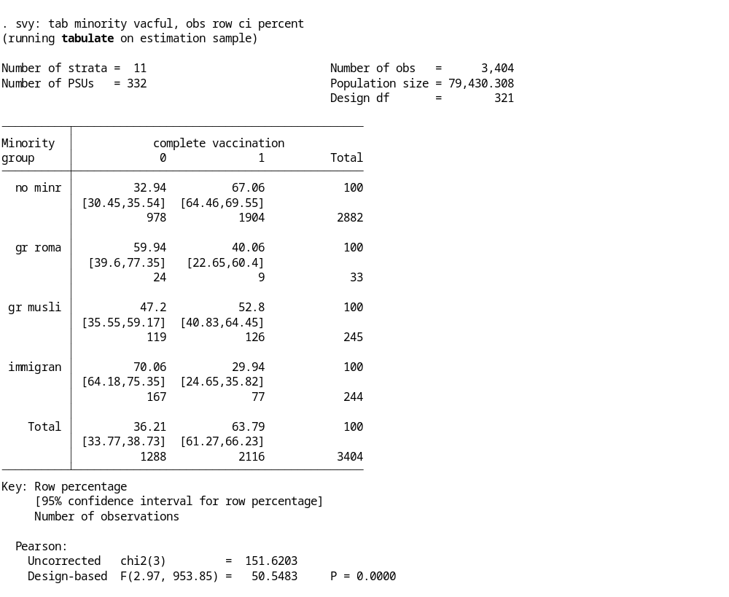

This table shows that 63.8% of children in Greece were fully vaccinated at the time of the survey. Among Roma, Greek Muslims and immigrant groups, the percentage of fully vaccinated children were 40.1% (95% CI: 22.7%-60.4%), 52.8% (95% CI: 40.8%-64.5%) and 29.9% (95% CI: 24.7%-35.8%), respectively. In comparison, 67.1% (95% CI: 64.5%-69.6%) of children in non-minority groups in Greece were fully vaccinated at the time of the survey.

Complete Table 5.2 with bivariate statistics for all potential exposure variables by following the above example. Interpret the results.

    - Crude associations. Measure the crude associations between each potential exposure variable (separately) and the outcome of having a fully vaccinated child. Below is an example using the exposure of parental perception of high cost of vaccines. Complete Table 5.2 by following this example. Use vaccine5.dta dataset. Interpret the results.

Stata command to calculate prevalence ratios using mixed-effects poisson regression with robust error variance:
xi: meglm vacful i.a3x4g || school:, family(poisson) link(log) vce(robust) eform
xi: meglm vacful i.a3x4g || school:, family(poisson) link(log) vce(robust) irr

Here is a description of the command options:

- family(family name) specifies the distribution of dependant variable
- link(link name) specifies the link function; the default is the canonical link for the family()
- eform displays the exponentiated coefficients and corresponding standard errors

Use help meglm to familiarize yourself with this command for fitting multilevel mixed-effects generalized linear models

Example outputs:

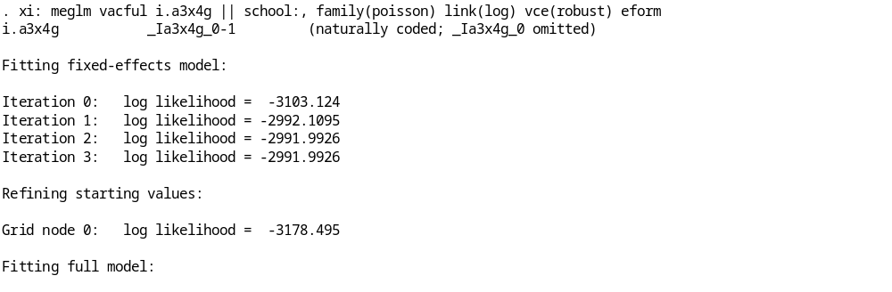
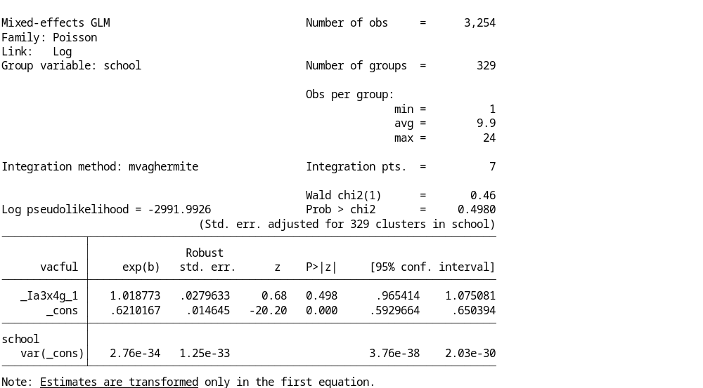

This prevalence ratio (PR) is 1.02 (95% CI: 0.97-1.08, p=0.498) indicating that there was no significant difference in the risk of having a fully vaccinated child among parents who perceived the cost of vaccines were a major barrier to immunization compared to those who did not hold this perception.

Complete Table 5.2 with the prevalence ratios of crude associations for each potential exposure variable with the outcome of having a fully vaccinated child. Interpret the results.

You may also complete Table 5.2 using the Stata loop command (foreach) for more efficient code.

Bivariate statistics:
foreach VAR in minority mageg educf osibg a1posyn a1posg uncritical a1x1g a1x2g a1x5g a3x1g a3x2g a3x5g {
svy:tab `VAR' vacful, obs row ci percent
}

Crude associations:
foreach VAR in minority mageg educf osibg a1posyn a1posg uncritical a1x1g a1x2g a1x5g a3x1g a3x2g a3x5g {
xi:meglm vacful i.`VAR' || school:, family(poisson) link(log) vce(robust) eform
}

The completed version of Table 5.2 should look like this:

Table 5.2- Crude prevalence ratios and bivariate statistics for fully vaccinated children by category of parental characteristics, beliefs/attitudes towards immunization, and perceived barriers to vaccination
Parents’ characteristics [variable name] |  | Fully vaccinated children  N (%*) |  | PR†  (95% CI‡)
Minority group [minority]  General population  Immigrants  Greek Muslims  Roma  Mother’s age at child’s birth (years) [mageg]  <25  25-29  ≥30  Father’s education [educf]  <9 years (Grammar school)  9 -11 years  12 years (high-school graduate)  College/University graduate  Number of other siblings [osib]  ≥3 other children  1-2 other children  Only child |  | 1904 (67.1)  77 (29.9)  126 (52.8)  9 (40.1)  13 (38.6)  247 (52.8)  1823 (65.8)  300 (55.9)  302 (58.5)  706 (64.6)  666 (70.5)  124 (48.6)  1630 (65.3)  336 (65.5) |  | 1.00  0.41 (0.23-0.74)  0.78 (0.64-0.94)  0.48 (0.39-0.58)  1.00  1.40 (0.90-2.18)  1.79 (1.17-2.75)  1.00  1.04 (0.92-1.18)  1.15 (1.04-1.28)  1.30 (1.17-1.43)  1.00  1.30 (1.13-1.48)  1.29 (1.11-1.49)
Parent’s opinions towards vaccination |  | Fully vaccinated children  N (%*) | PR†  (95% CI‡)
Balanced positive opinion on vaccination§  [a1posyn]  strong  moderate  no positive opinion  Uncritical positive opinion on vaccination [uncritical]  Vaccination is necessary for my child [a1x1g]  Vaccines may harm my child [a1x2g]  Natural childhood disease preferable to vaccination [a1x5g] | Yes  No  Yes  No  Yes  No  Yes  No  Yes  No | 1993 (64.5)  24 (52.3)  1663 (65.5)  330 (59.6)  24 (52.3)  988 (63.1)  1068 (65.2)  2093 (64.0)  2 (51.1)  64 (54.9)  1882 (64.5)  359 (58.6)  1637 (65.6) |  | 1.47 (1.10-1.95)  1.00  1.34 (1.01-1.81)  1.49 (1.12-2.00)  1.00  0.97 (0.92-1.02)  1.00  1.55 (0.53-4.57)  1.00  0.77 (0.65-0.93)  1.00  0.90 (0.84-0.97)  1.00
Perceived barriers to vaccination |  | Fully vaccinated children  N (%*) |  |  | PR†  (95% CI‡)
Long distance to immunization site [a3x1g]  Inconvenient opening hours [a3x2g]  Cost of vaccines[a3x5g] | Yes  No  Yes  No  Yes  No | 356 (56.0)  1700 (66.0)  383 (59.6)  1646 (65.3)  795 (63.8)  1244 (64.4) |  | 0.83 (0.77-0.89)  1.00  0.89 (0.83-0.96)  1.00  1.02 (0.97-1.08)  1.00
* Weighted proportion that allows for sample weights and clustering within school classes
† Prevalence Ratio
‡ 95% Confidence Interval
§ For definitions, please refer to paragraph above

Interpreting Table 5.2 results:

Socioeconomic factors
Based on crude prevalence ratios (unadjusted for other factors) (Table 5.2), children were less likely to be fully vaccinated if they belonged to a minority group, were born to a younger mother, had 3+ siblings, or their father was less educated.

Beliefs and attitudes towards immunization
Based on crude prevalence ratios (unadjusted for other factors) (Table 5.2), children were less likely to be fully vaccinated if the parents held negative opinions about vaccination, believed that vaccines may harm their child, or believed that natural childhood disease is preferable to vaccination compared to parents who did not hold these beliefs.

Barriers to immunization
Based on crude prevalence ratios (unadjusted for other factors) (Table 5.2), children were less likely to be fully vaccinated if their parents believed that it was a long distance to the immunization site or if they believed the immunization site had inconvenient opening hours compared to parents who did not hold these beliefs.

OPTIONAL EXERCISE – CALCULATING CRUDE ODDS RATIOS

    - Crude associations. Calculate the odds ratios for crude associations of each potential exposure variable (separately) and the outcome of having a fully vaccinated child. Below is an example using the exposure of parental perception of high cost of vaccines. Follow this example to estimate the crude association between one additional exposure variable and the study outcome, as an optional exercise. Interpret the result.

    - Be careful to interpret results as the odds of the outcome, rather than a risk of the outcome since odds ratios overestimate risk ratios in situations where the outcome is common (>10% prevalence), as in this case study. When an outcome is rare, the odds ratio approximates the risk ratio and may be correctly interpreted as a risk of the outcome. In these situations, it may be preferable to calculate the odds ratio using logistic regression models.

Stata command to calculate odds ratios using mixed-effects logistic regression models:
xi: xtmelogit vacful i.a3x4g || school:, var or OR xi: meqrlogit vacful i.a3x4g || school:, var or

Use help meqrlogit or xtmelogit to familiarize yourself with the commands for fitting mixed-effects logistic regression models.

Example outputs:

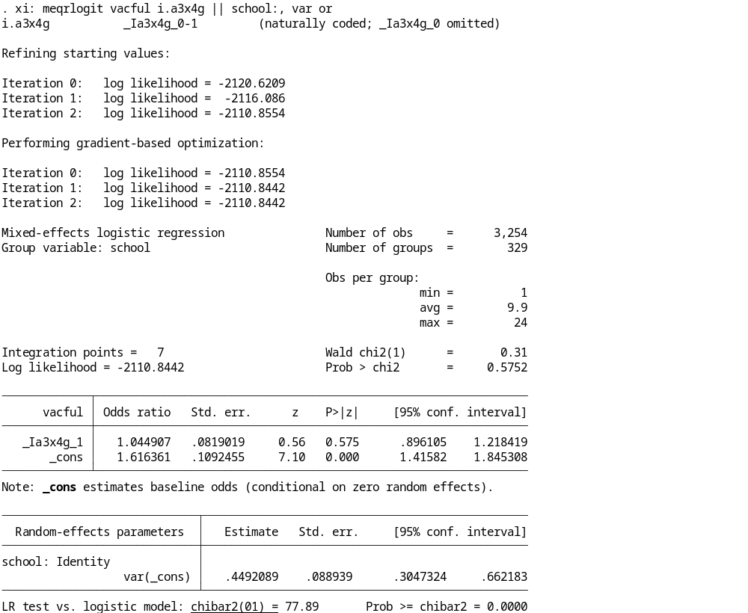

This crude odds ratio (OR) is 1.04 (95% CI: 0.90-1.22, p=0.575) indicating that there was no significant difference in the odds of having a fully vaccinated child among parents who perceived the cost of vaccines were a barrier to immunization compared to those who did not hold this perception.

Table 5.2a presents complete results with the crude odds ratios for each potential exposure variable with the outcome of having a fully vaccinated child. Interpret the results (be careful to interpret as an odds of the outcome rather than a risk of the outcome!).

Crude associations using the Stata loop command (foreach) for more efficient code:
foreach VAR in minority mageg educf osibg a1posyn a1posg uncritical a1x1g a1x2g a1x5g a3x1g a3x2g a3x5g {
xi: meqrlogit vacful i.`VAR' || school:, var or
}
Table 5.2a Crude odds ratios and bivariate statistics for fully vaccinated children by category of parental characteristics, beliefs/attitudes towards immunization, and perceived barriers to vaccination
Parents’ characteristics [variable name] |  | Fully vaccinated children  N (%) |  | Crude Odds Ratio  (95% CI)
Minority group [minority]  General population  Immigrants  Greek Muslims  Roma  Mother’s age at child’s birth (years) [mageg]  <25  25-29  ≥30  Father’s education [educf]  <9 years (Grammar school)  9 -11 years  12 years (high-school graduate)  College/University graduate  Number of other siblings [osib]  ≥3 other children  1-2 other children  Only child |  | 1904 (67.1)  77 (29.9)  126 (52.8)  9 (40.1)  13 (38.6)  247 (52.8)  1823 (65.8)  300 (55.9)  302 (58.5)  706 (64.6)  666 (70.5)  124 (48.6)  1630 (65.3)  336 (65.5) |  | 1.00  0.21 (0.15-0.28)  0.54 (0.38-0.76)  0.17 (0.07-0.42)  1.00  1.71 (0.81-3.59)  2.93 (1.42-6.07)  1.00  1.08 (0.84-1.40)  1.41 (1.12-1.77)  2.02 (1.58-2.59)  1.00  1.85 (1.40-2.45)  1.83 (1.32-2.54)
Parent’s opinions towards vaccination |  | Fully vaccinated children  N (%) | Crude Odds Ratio  (95% CI)
Balanced positive opinion on vaccination§  [a1posyn]  strong  moderate  no positive opinion  Uncritical positive opinion on vaccination [uncritical]  Vaccination is necessary for my child [a1x1g]  Vaccines may harm my child [a1x2g]  Natural childhood disease preferable to vaccination [a1x5g] | Yes  No  Yes  No  Yes  No  Yes  No  Yes  No | 1993 (64.5)  24 (52.3)  1663 (65.5)  330 (59.6)  24 (52.3)  988 (63.1)  1068 (65.2)  2093 (64.0)  2 (51.1)  64 (54.9)  1882 (64.5)  359 (58.6)  1637 (65.6) |  | 2.27 (1.28-4.03)  1.00  2.39 (1.34-4.25)  1.81 (1.00-3.29)  1.00  0.91 (0.78-1.05)  1.00  2.63 (0.40-17.58)  1.00  0.54 (0.37-0.80)  1.00  0.78 (0.65-0.94)  1.00
Perceived barriers to vaccination |  | Fully vaccinated children  N (%) |  |  | Crude Odds Ratio  (95% CI)
Long distance to immunization site [a3x1g]  Inconvenient opening hours [a3x2g]  Cost of vaccines[a3x5g] | Yes  No  Yes  No  Yes  No | 356 (56.0)  1700 (66.0)  383 (59.6)  1646 (65.3)  795 (63.8)  1244 (64.4) |  | 0.68 (0.56-0.82)  1.00  0.78 (0.65-0.94)  1.00  1.07 (0.91-1.25)  1.00

Task 5.3 – Estimate adjusted associations with having a fully vaccinated child

Continue with the previous dataset (vaccine5.dta).

- Test for multicollinearity among potential exposure variables prior to multivariable modelling.
- Use the Wald test to determine which independent exposures contribute significantly to the model fit in order to build the final model.
- Calculate adjusted measures of association, with corresponding 95% CI, for independent exposures included in the final model (simplest adequate model).
- Complete Table 5.3. Interpret the results.

To complete the work in this session, you will need:

- Install the Stata user written command (collin)to test for multicollinearity among variables.
- Work your way towards a final model (the simplest adequate model). Run an initial model that includes all the exposure variables from Table 5.2 (session 5) and using the same multilevel model to adjust for data clustering within primary sampling units. Include all exposure variables in this model as fixed effects nested within the primary sampling unit (school).

- Use the Wald test to see which independent variables contribute significantly to the model fit in order to build the final model (simplest adequate model).

- Complete Table 5.3 with adjusted measures of association, and corresponding 95% CI, for final model (simplest adequate model). Interpret the results.

Note that this case study is not intended to cover multivariable or multilevel analysis in depth since this was previously covered in the Multivariable analysis course. It further applies the methods taught in the MVA course.

Help, Task 5.3

    - Multicollinearity: The problem of multicollinearity in regression analyses occurs when two or more exposure variables are highly correlated to each other such that they do not provide unique or independent information in the regression model. This issue causes problems with model fit, reduces the precision of regression coefficients, and increases corresponding standard errors. Check for multicollinearity among all potential exposure variables prior to multivariable modelling.

findit collin // Finds the site for the user-written ‘collin’ command
Click on the last link on that page:
https://stats.oarc.ucla.edu/stat/stata/ado/analysis/
Click on the ‘collin’ package for collinearity diagnostics
Click the link to install the package

help collin Type the help command for more information on this user-written package to test for collinearity diagnostics

Stata command to test for multicollinearity problems among potential exposure variables:
collin minority mageg educf osibg a1posyn a1posg uncritical a1x1g a1x2g a1x5g a3x1g a3x2g

Example outputs:

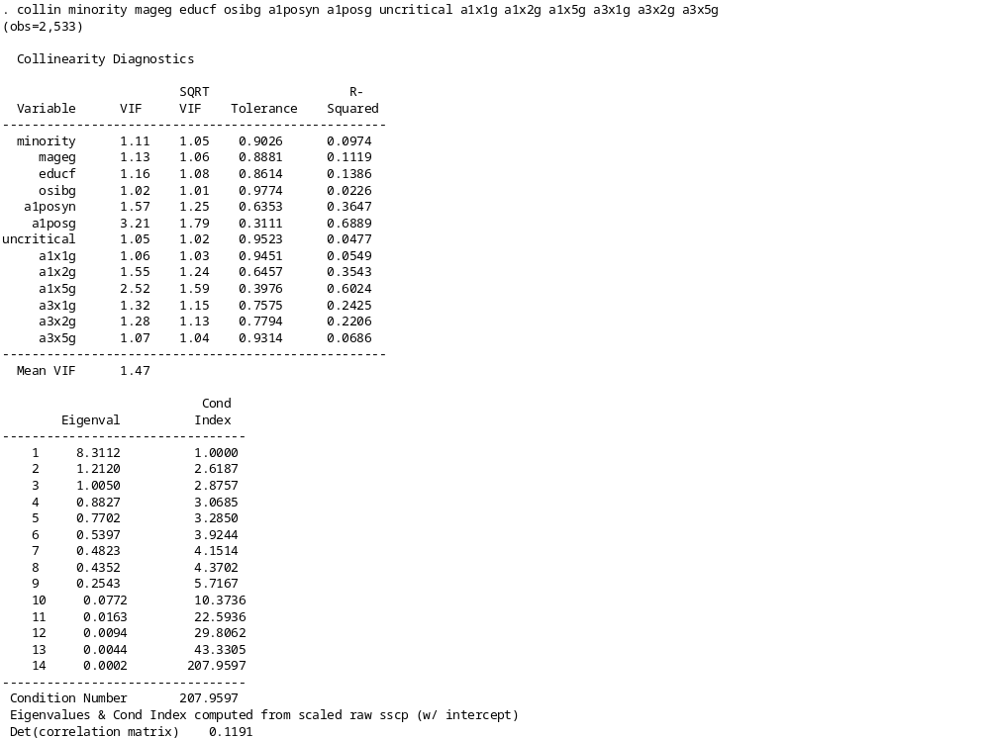

Interpret the results:
We can use the variance inflation factor (VIF) to check for multicollinearity. As a rule of thumb, a variable whose VIF values are greater than 10 may merit further investigation. In this case, a correlation matrix may help to further identify the correlated variables. Tolerance, defined as 1/VIF, is also used to check for collinearity and a value of lower than 0.10 is comparable to a VIF of 10. Some remedies for multicollinearity include deleting the correlated variables, collecting additional data, or recoding variables in a different way to reduce correlation.
There is no significant correlation among the potential exposure variables in this analysis.

regression analysis (final model)

- Working with indicator (dummy) variables: All potential exposure variables will be included in regression models as indicator (dummy) variables. Indicator variables are directly included regression models in Stata using ‘xi:’ at the start of the model command and ‘i.’ added to the start of the indicator variable. If a reference category is not specified, the model will automatically select the lowest value among the variable levels as the reference category. Review the reference levels used in the crude analysis. Determine if a different reference category should be used in the final model (e.g. is it appropriate to estimate the risk of having a fully vaccinated child for older mothers relative to the reference of youngest mothers?).

Example:

Change the reference category for the variable minority so that the model output shows the risk of having a fully vaccinated child for different groups relative to Roma (rather than the default of the non-minority group used in the crude analysis).
Check the reference levels for the minority variable. The change of reference level may be specified directly in the model, see next section (e.g., b1.i.minority to set the reference level to Roma or b2.i.minority to set the reference level to Muslim as examples).

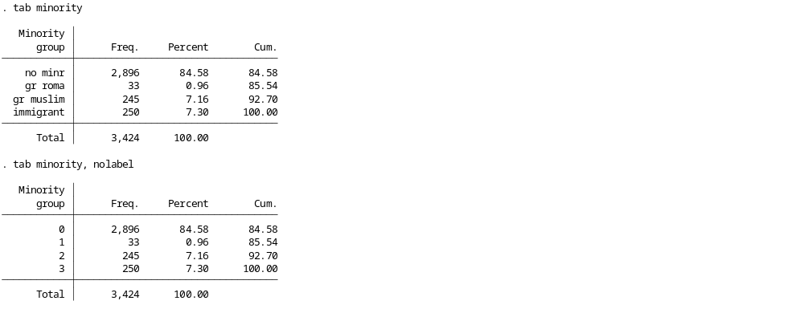

    - Identify exposure variables for final model: The Stata command testparm performs an adjusted Wald test to see if independent variables contribute significantly to the model fit. The Wald test is used to compare the log-likelihood of the model including the variable (full model) with the log-likelihood of the model excluding the variable (reduced model). In other words, it assesses the overall contribution of a variable to the model. This gives a measure of how much a variable improves the fit of a model to observed data compared to a model without that variable. The likelihood ratio (LR) test is invalid for models with data clustering as occurs in this case study.

First, run the full model with the outcome and all potential exposure variables.

xi: meglm vacful b1.i.minority i.mageg i.educf i.osibg i.a1posyn i.a1posg i.uncritical i.a1x1g i.a1x2g i.a1x5g i.a3x1g i.a3x2g || school:, family(poisson) link(log) vce(robust) eform

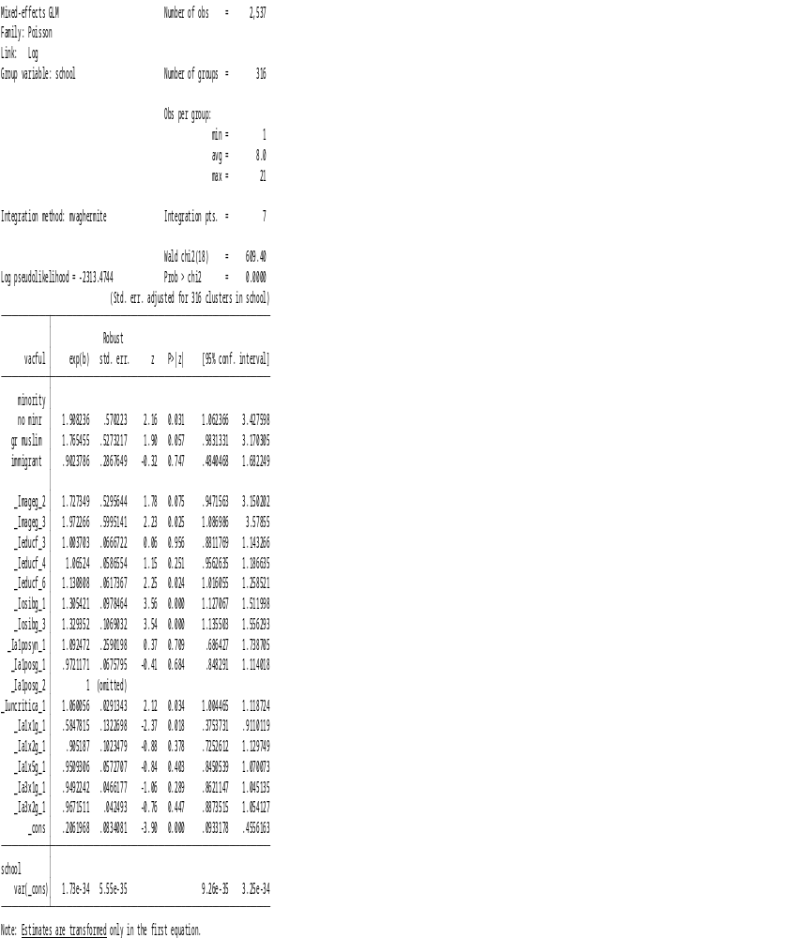

- After the full regression model is run, perform the adjusted Wald test using the testparm command for each exposure variable separately. Interpret the results. Work your way towards a final model (the simplest adequate model) by following the examples below.

Example testparm command and outputs:
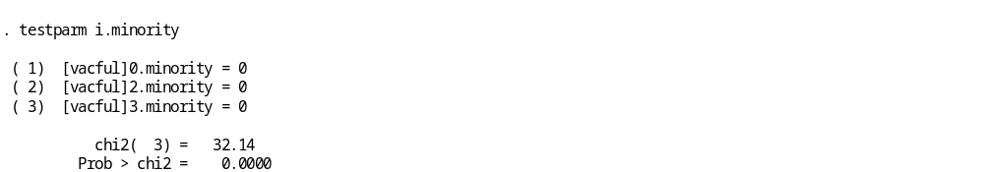

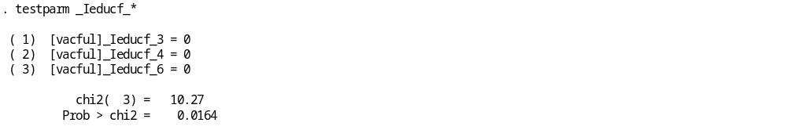
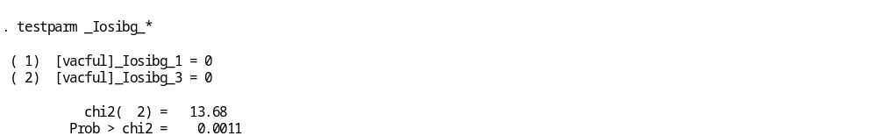
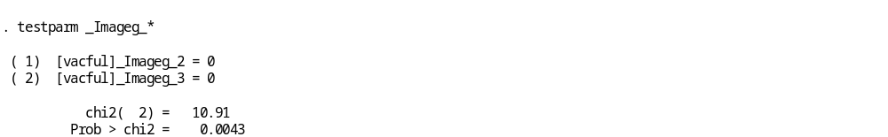

All of the above p-values suggest that each variable tested contributes significantly to the model fit. These variables must therefore be included in the final adjusted model. Follow this example to test all other variables for inclusion in the final adjusted model (simplest adequate model). Specify the final model, complete Table 5.3, and interpret the results.

The final model (simplest adequate model) should look like this:

xi: meglm vacful b1.i.minority i.mageg i.educf i.osibg i.a1x1g || school:, family(poisson) link(log) vce(robust) eform

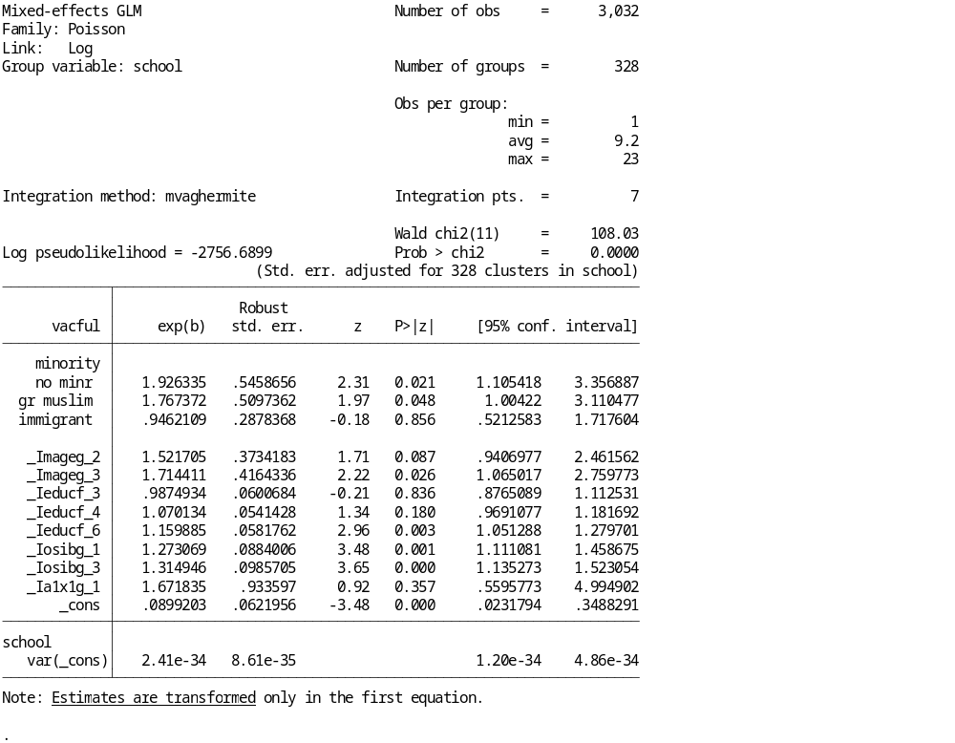
The completed Table 5.3 should look like this:

odel)

Table 5.3 Adjusted associations for having a fully vaccinated child (simplest adequate model)
Variable [variable name] | Adjusted RR†  for fully vaccinated child  Final model  (95% CI‡)  N=3032 | p-value
Minority group [minority]  Roma  Immigrants  Greek Muslims  Non-minority population  Number of other siblings [osibg]  ≥3 other children  1-2 other children  Only child  Vaccination is necessary for my child[a1x1g]  No  Yes  Mother’s age at child’s birth (years) [mageg]  <25  25-29  ≥25  Father’s education [educf]  <9 years (Grammar school)  9 -11 years  12 years (high school graduate)  College/University graduate | 1.00  0.95 (0.52-1.72)  1.77 (1.00-3.11)  1.93 (1.11-3.36)  1.00  1.27 (1.11-1.46)  1.31 (1.14-1.52)  1.00  1.67 (0.56-4.99)  1.00  1.52 (0.94-2.46)  1.71 (1.07-2.76)  1.00  0.99 (0.88-1.11)  1.07 (0.97-1.18)  1.16 (1.05-1.28) | 0.856  0.048  0.021  0.001  <0.001  0.357  0.087  0.026  0.836  0.180  0.003

† Relative Risk adjusted for all variables in the table (simplest adequate model)
‡ 95% Confidence Interval

Conclusions
Summarising the results.
This study identified several independent determinants of complete vaccination status among 6-year old Greek school children included in the survey. Complete vaccination coverage was significantly lower among children who belonged to a minority group, who had siblings in the household, whose mothers were <30 years, whose father had low educational levels, and whose parents/guardians did not believe that vaccination was necessary for a child. These findings indicate that socioeconomic factors may be more important determinants of immunization coverage than parental immunization beliefs and perceived barriers to vaccination.

Recommendations

- Based on the findings of this study, the following identified groups merit increased attention in future interventions designed to improve immunization delivery in Greece:
i) minority groups, especially Roma and immigrants,
ii) families with many children,
iii) young mothers, and
iv) households headed by fathers with low educational level, possible reflecting low socioeconomic status of the families.
- Interventions aimed at those high-risk families, although difficult to deliver, may have the greatest effects on community immunization rates.
- In addition, parents/guardians must be educated about the necessity of vaccinations for children’s health.
- There is a need for policies to overcome structural and health care system barriers to immunization, and identify effective and comprehensive approaches for improving the immunization levels of children in high-risk groups.

References
Cast study
- Danis K, Georgakopoulou T, Stavrou T, Laggas D, Panagiotopoulos T. Socioeconomic factors play a more important role in childhood vaccination coverage than parental perceptions: a cross-sectional study in Greece. Vaccine. 2010 Feb 17;28(7):1861-9. Epub 2010 Jan 19.

- K. Danis, T. Georgakopoulou, T. Stavrou, D. Laggas, T. Panagiotopoulos . Predictors Of Childhood Vaccination Uptake: A Cross-sectional Study In Greece.
Procedia in Vaccinology, Volume 2, Issue 1, 2010, Pages 86-91. Available at:
http://www.sciencedirect.com/science?_ob=ArticleURL&_udi=B986S-4YVHHGW-H&_user=10&_rdoc=1&_fmt=high&_orig=rslt_list&_origin=rslt_list&_zone=top&_sort=d&view=c&_acct=C000050221&_version=1&_urlVersion=0&_userid=10&md5=2a25d31dee16a470c2550e178c5079ef&searchtype=a
Prevalence ratio versus odds ratio
- Barros AJD, Hirakata VN. Alternatives for logistic regression in cross-sectional studies: an empirical comparison of models that directly estimate the prevalence ratio. BMC Medical Research Methodology 2003; 3:21.
- Zou G. A modified poisson regression approach to prospective studies with binary data. Am J Epidemiol 2004; 159:702.
Model- versus design-based approaches to complex survey analysis
- Skinner C, Wakefield J. Introduction to the design and analysis of complex survey data. Statistical Sci 2017; 32:165.
- Lovasi GS, Fink DS, Mooney SJ, Link BG. Model-based and design-based inference goals frame how to account for neighborhood clustering in studies of health in overlapping context types. Population Health 2017; 3:600.

Annex 1: School registry extraction form
Form 1. List of students in school-class

District: . . . . . . . . . . . . . . . . School/Class: . . . . . . . . . . . . . . . . . . . . . . . . . . . . . . . . . . Total number of students in school class: . . . . . .
 | SCHID(1) | Student’s Surname and Name | Gender |  | Date of birth |  |  | Country of birth | Minority group (2) |  |  |  |  | Question-naire  received | Vaccination record received | Date of receiving vaccination record
 | SCHID(1) | Student’s Surname and Name | Male | Female | DAY | MONTH | YEAR
(3) | 4 | Papadopoulou Maria | 1 | 2 | 23 | 6 | 99 | GR | 0 | 1 | 2 | 3 | 9 |  |  | 8/12
₁ |  |  | 1 | 2 |  |  |  |  | 0 | 1 | 2 | 3 | 9
₂ |  |  | 1 | 2 |  |  |  |  | 0 | 1 | 2 | 3 | 9
₃ |  |  | 1 | 2 |  |  |  |  | 0 | 1 | 2 | 3 | 9
₄ |  |  | 1 | 2 |  |  |  |  | 0 | 1 | 2 | 3 | 9
₅ |  |  | 1 | 2 |  |  |  |  | 0 | 1 | 2 | 3 | 9
₆ |  |  | 1 | 2 |  |  |  |  | 0 | 1 | 2 | 3 | 9
₇ |  |  | 1 | 2 |  |  |  |  | 0 | 1 | 2 | 3 | 9
₈ |  |  | 1 | 2 |  |  |  |  | 0 | 1 | 2 | 3 | 9
₉ |  |  | 1 | 2 |  |  |  |  | 0 | 1 | 2 | 3 | 9
₁₀ |  |  | 1 | 2 |  |  |  |  | 0 | 1 | 2 | 3 | 9
₁₁ |  |  | 1 | 2 |  |  |  |  | 0 | 1 | 2 | 3 | 9
₁₂ |  |  | 1 | 2 |  |  |  |  | 0 | 1 | 2 | 3 | 9
₁₃ |  |  | 1 | 2 |  |  |  |  | 0 | 1 | 2 | 3 | 9
₁₄ |  |  | 1 | 2 |  |  |  |  | 0 | 1 | 2 | 3 | 9
₁₅ |  |  | 1 | 2 |  |  |  |  | 0 | 1 | 2 | 3 | 9
₁₆ |  |  | 1 | 2 |  |  |  |  | 0 | 1 | 2 | 3 | 9
(1)SCHID: Student’s ID in school class (2) 0: no minority group 1: Greek Roma 2: Greek Muslim 3:Immigrant 9:Unknown (3) Example of completion

Annex 2: Vaccination Beliefs Questionnaire

Vaccination Beliefs Questionnaire

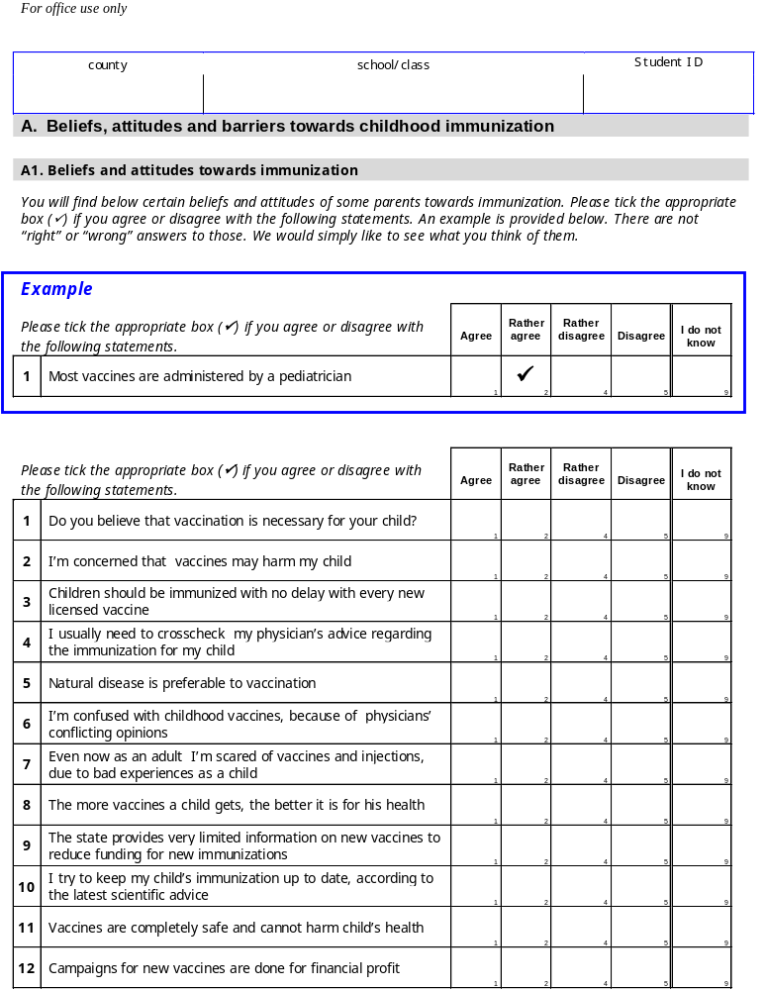
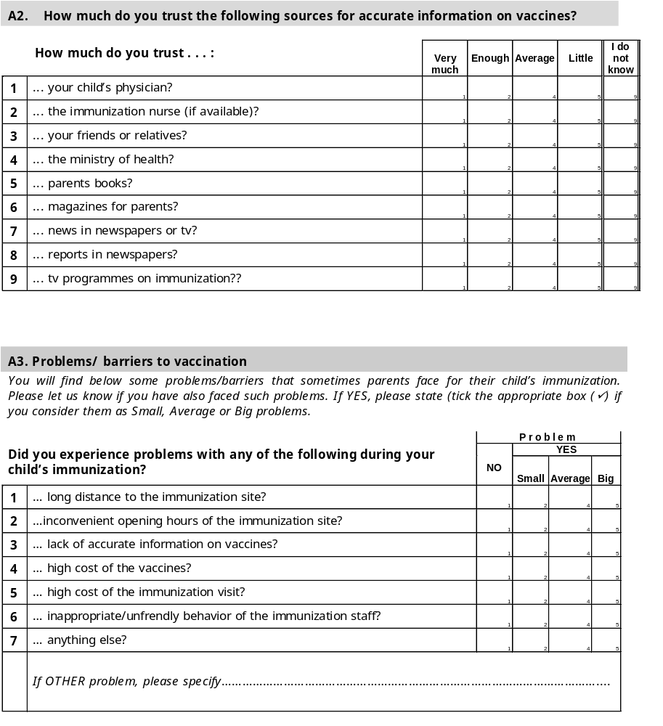
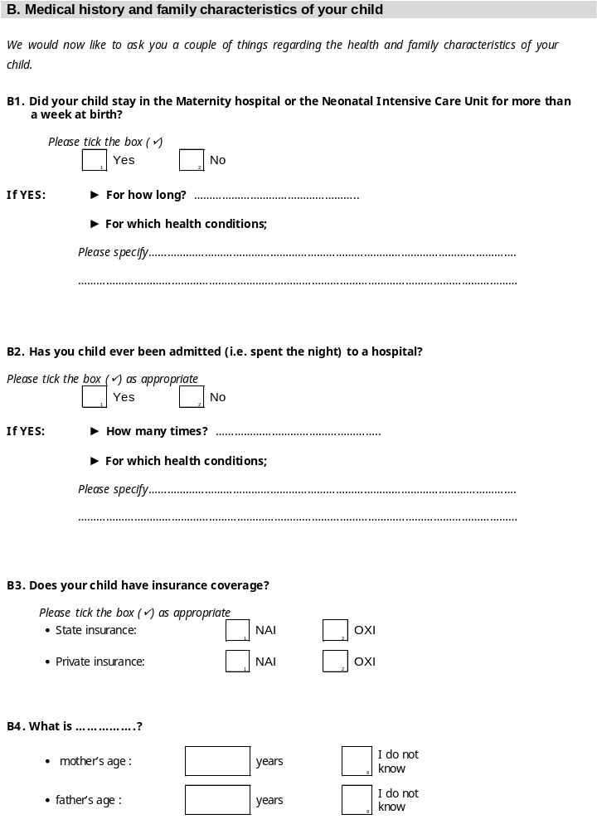
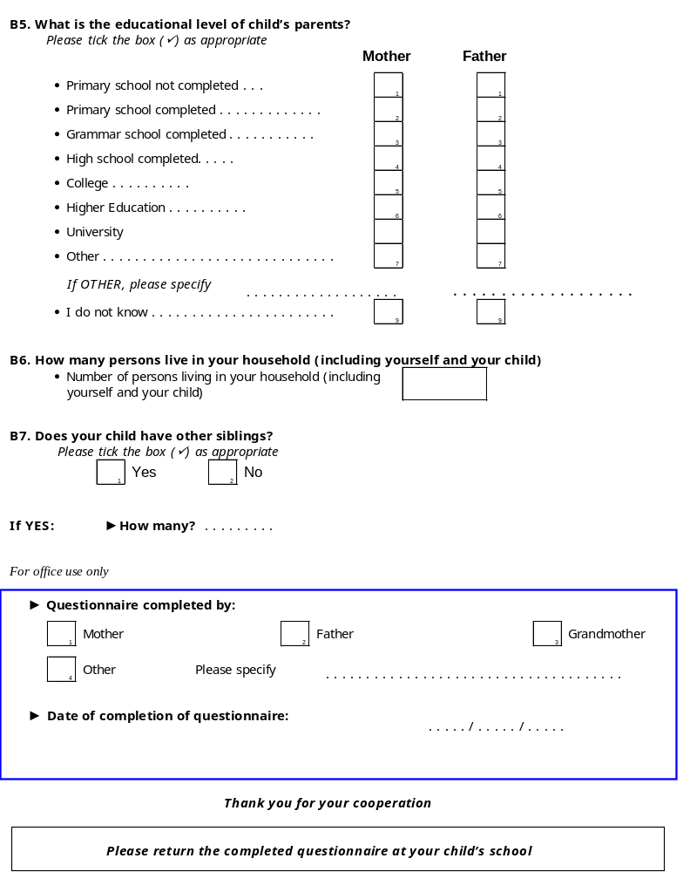

Annex 3: Vaccination Abstraction Form
Vaccination Abstraction Form
Code
► Region: |  |  |  | [REGION]
► School/Class: |  |  |  | [SCHOOL]
► Surname / Name: |  |  |  | [SCHID]
► Gender: | 1. MALE 2. FEMALE 9. UNKNOWN |  |  | [GENDER]
► Date of birth: | └───┴───┘ / └───┴───┘ / └───┴───┘ |  |  | [DOB]
► Field worker: |  |  |  | [FIELDW]
► Date of vaccination record collection: |  | └───┴───┘ / └───┴───┘ / └───┴───┘ |  | [DATECOL]
► Record type: | 1. HEALTH BOOKLET 2. VACCINATION CARD 3. OTHER |  |  | [RECT]
Vaccines/doses carried out by child
For each vaccine/dose, write down: 1. whether vaccination was done (check Y/N) (circle appropriate option),
2. date of vaccination (DD/MM/YY),
3. vaccine type, where necessary (circle appropriate option).
1) Vaccines of National Vaccination Programme starting at 1st year of life
 |  | Dose 1 |  | Dose 2 |  | Dose 3 |  | Dose 4 |  | Dose 5 |  | Dose 6
DTP |  | Y | N | Y | N | Y | N | Y | N | Y | N | Y | N
DTP | DATE |  |  |  |  |  |  |  |  |  |  |  |  | [DTP-]
POLIO |  | Y | N | Y | N | Y | N | Y | N | Y | N | Y | N
POLIO | DATE |  |  |  |  |  |  |  |  |  |  |  |  | [POL-]
Vaccine type |  | OPV - IPV - UNK |  | OPV - IPV - UNK |  | OPV - IPV - UNK |  | OPV - IPV - UNK |  | OPV - IPV - UNK |  | OPV - IPV - UNK |  | [POLTYP-]

 |  | Dose 1 |  | Dose 2 |  | Dose 3 |  | Dose 4
HIB |  | Y | N | Y | N | Y | N | Y | N
HIB | DATE |  |  |  |  |  |  |  |  | [HIB-]
HEP B |  | Y | N | Y | N | Y | N | Y | N
HEP B | DATE |  |  |  |  |  |  |  |  | [HBV-]
MEN C |  | Y | N | Y | N |  | N | Y | N
MEN C | DATE |  |  |  |  |  |  |  |  | [MEN-]
PNEUMO |  | Y | N | Y | N |  | N | Y | N
PNEUMO | DATE |  |  |  |  |  |  |  |  | [PNU-]

2) Vaccines of National Vaccination Programme starting at 2nd year of life
 |  | Dose 1 |  | Dose 2 |  | Dose 3 |  | Dose 4
MMR |  | Y | N | Y | N | Y | N | Y | N
MMR | DATE |  |  |  |  |  |  |  |  | [MMR-]
MEASLES |  | Y | N | Y | N |  | N | Y | N
MEASLES | DATE |  |  |  |  |  |  |  |  | [MSL-]
RUBELLA |  | Y | N | Y | N |  | N | Y | N
RUBELLA | DATE |  |  |  |  |  |  |  |  | [RUB-]
MUMPS |  | Y | N | Y | N |  | N | Y | N
MUMPS | DATE |  |  |  |  |  |  |  |  | [MUM-]

3) BCG, INFLUENZA
 |  | First dose |  | Last dose |  | Total number of doses
BCG |  | Y | N | Y | N | [BCGN]
BCG | DATE |  |  |  |  | [BCGN] | [BCG-]
INFLU-  ENZA |  | Y | N | Y | N | [FLUN]
INFLU-  ENZA | DATE |  |  |  |  | [FLUN] | [FLU-]

4) Other vaccines / special indications
 |  | Dose 1 |  | Dose 2 |  | Dose 3 |  | Dose 4
VARI-  CELLA |  | Y | N | Y | N | Y | N | Y | N
VARI-  CELLA | DATE |  |  |  |  |  |  |  |  | [VAR-]
HEP A |  | Y | N | Y | N | Y | N | Y | N
HEP A | DATE |  |  |  |  |  |  |  |  | [HAV-]

OTHER |  | Y | N |  |  |  |  |  |  | [OTHER]
OTHER-A |  | Y | N | Y | N | Y | N | Y | N
OTHER-A | DATE |  |  |  |  |  |  |  |  | OTHERA-]
OTHER-B |  | Y | N | Y | N | Y | N | Y | N
OTHER-B | DATE |  |  |  |  |  |  |  |  | OTHERB-]

Place of vaccination: public/private sector
(Circle appropriate option)

 | NO VACCINATION | PUBLIC SECTOR | PRIVATE SECTOR | VACCINATION ABROAD | UNKNOWN SECTOR
DTP - dose 1 | 0 | 1 | 2 | 3 | 9 | [DTP1PLC]
DTP - dose 4 | 0 | 1 | 2 | 3 | 9 | [DTP4PLC]
DTP - dose 5 | 0 | 1 | 2 | 3 | 9 | [DTP5PLC]
HIB - dose 1 | 0 | 1 | 2 | 3 | 9 | [HIB1PLC]
HEP B - dose 1 | 0 | 1 | 2 | 3 | 9 | [HBV1PLC]
MEN C - dose 1 | 0 | 1 | 2 | 3 | 9 | [MEN1PLC]
PNEUMO - dose 1 | 0 | 1 | 2 | 3 | 9 | [PNU1PLC]
MMR (OR MCV*) - dose 1 | 0 | 1 | 2 | 3 | 9 | [MCV1PLC]
MMR (OR MCV*) - dose 2 | 0 | 1 | 2 | 3 | 9 | [MCV2PLC]
BCG - dose 1 | 0 | 1 | 2 | 3 | 9 | [BCG1PLC]
Influenza - dose 1 | 0 | 1 | 2 | 3 | 9 | [FLU1PLC]
Varicella - dose 1 | 0 | 1 | 2 | 3 | 9 | [VAR1PLC]
HEP A - dose 1 | 0 | 1 | 2 | 3 | 9 | [HAV1PLC]
* measles containing vaccine

Annex 4: Fieldworker’s check-list of actions
Form 2. Fieldworker’s check-list of actions

District: . . . . . . . . . . . . . . . . . . . . School/Class: . . . . . . . . . . . . . . . . . . . . . . . . . . . . . . . . .
 | SCHID (1) | Student’s Surname and Name | Letter & Questionnaire given | Date that Questionnaire was given | Completed Questionnaire received | Vaccination record received | Date that Vaccination record was received | Photocopy of vaccination record | Check of photocopies and fill in gaps | Prepare feedback note on vaccination status for parents | Return vaccination record + feedback note to parents
 | 4 | Papadopoulou Mary |  | 6/12 |  |  | 8/12 |  |  |  | 
₁
₂
₃
₄
₅
₆
₇
₈
₉
₁₀
₁₁
₁₂
₁₃
₁₄
₁₅
₁₆
₁₇
(1)SCHID: Student’s ID in school class

Annex 5: Description of “school” database

Dataset name: school.dta
Variable name | Type | Stata code | Definition
school | Numeric |  | School/Class
schid | Numeric |  | Student’s ID in school class
vaccrec | Numeric | 0:No, 1:Yes | Vaccination Booklet received
qsrec | Numeric | 0:No, 1:Yes | Questionnaire received
id | Numeric |  | (school x 100)+schid
region | Numeric
urban | Numeric | 0: Rural, 1:Urban | Rural/Urban
gender | Numeric | 0:Female, 1:Male, 9:Unknown | Gender (from school record)
dob1 | Date |  | Date of birth (from school record)
country | String |  | Country of birth
minority | Numeric |  | Minority group
minoryn | Numeric | 0:No, 1:Yes, 9:Unknown | Belongs to minority group
datecol | Date |  | Date of booklet collection

Annex 6: Description of “vaccine” database

Dataset name: vaccine.dta
Variable name | Type | Stata code | Definition
id | Numeric |  | Unique identifier of students
weight | Numeric
datecol | Numeric |  | Date of booklet collection
agey | Numeric |  | Age in years
dob | Date |  | Date of birth (from vaccination booklet)
dtp1 | Date |  | 1st dose of DTP vaccine
dtp2 | Date |  | 2nd dose of DTP vaccine
dtp3 | Date |  | 3rd dose of DTP vaccine
dtp4 | Date |  | 4th dose of DTP vaccine
dtp5 | Date |  | 5th dose of DTP vaccine
po1 | Date |  | 1st dose of Polio vaccine
po2 | Date |  | 2nd dose of Polio vaccine
po3 | Date |  | 3rd dose of Polio vaccine
po4 | Date |  | 4th dose of Polio vaccine
po5 | Date |  | 5th dose of Polio vaccine
potyp1 | Numeric | 1:OPV, 2:IPV, 9:Unknown | Polio 1st dose vaccine type
potyp2 | Numeric | 1:OPV, 2:IPV, 9:Unknown | Polio 2nd dose vaccine type
potyp3 | Numeric | 1:OPV, 2:IPV, 9:Unknown | Polio 3rd dose vaccine type
potyp4 | Numeric | 1:OPV, 2:IPV, 9:Unknown | Polio 4th dose vaccine type
potyp5 | Numeric | 1:OPV, 2:IPV, 9:Unknown | Polio 5th dose vaccine type
bcg1 | Date |  | 1st dose of BCG vaccine
bcgl | Date |  | Last dose of BCG vaccine
bcgn | Numeric |  | Total number of BCG vaccine doses
msl1 | Date |  | 1st dose of Measles vaccine
msl2 | Date |  | 2nd dose of Measles vaccine
msl3 | Date |  | 3rd dose of Measles vaccine
rub1 | Date |  | 1st dose of Rubella vaccine
rub2 | Date |  | 2nd dose of Rubella vaccine
rub3 | Date |  | 3rd dose of Rubella vaccine
mu1 | Date |  | 1st dose of Mumps vaccine
mu2 | Date |  | 2nd dose of Mumps vaccine
mu3 | Date |  | 3rd dose of Mumps vaccine
mmr1 | Date |  | 1st dose of MMR vaccine
mmr2 | Date |  | 2nd dose of MMR vaccine
mmr3 | Date |  | 3rd dose of MMR vaccine
hbv1 | Date |  | 1st dose of HBV vaccine
hbv2 | Date |  | 2nd dose of HBV vaccine
hbv3 | Date |  | 3rd dose of HBV vaccine
hbv4 | Date |  | 4th dose of HBV vaccine
hav1 | Date |  | 1st dose of HAV vaccine
hav2 | Date |  | 2nd dose of HAV vaccine
hav3 | Date |  | 3rd dose of HAV vaccine
hav4 | Date |  | 4th dose of HAV vaccine
hib1 | Date |  | 1st dose of HIB vaccine
Variable name | Type | Stata code | Definition
hib2 | Date |  | 2nd dose of HIB vaccine
hib3 | Date |  | 3rd dose of HIB vaccine
hib4 | Date |  | 4th dose of HIB vaccine
mnc1 | Date |  | 1st dose of MEN C vaccine
mnc2 | Date |  | 2nd dose of MEN C vaccine
mnc3 | Date |  | 3rd dose of MEN C vaccine
mnc4 | Date |  | 4th dose of MEN C vaccine
flu1 | Date |  | 1st dose of Influenza vaccine
flul | Date |  | Last dose of Infuenza vaccine
flun | Date |  | Total number of Influenza vaccine doses
var1 | Date |  | 1st dose of Varicella vaccine
var2 | Date |  | 2nd dose of Varicella vaccine
pne1 | Date |  | 1st dose of Pneumo vaccine
pne2 | Date |  | 2nd dose of Pneumo vaccine
pne3 | Date |  | 3rd dose of Pneumo vaccine
pne4 | Date |  | 4th dose of Pneumo vaccine
other | Numeric | 0:No, 1:Yes | Other vaccine YES/NO
dtp1plc | Numeric | 0:No vaccination, 1: State, 2:Private, 3:Abroad | Place of DTP-1 administration
dtp4plc | Numeric | 0:No vaccination, 1: State, 2:Private, 3:Abroad | Place of DTP-4 administration
dtp5plc | Numeric | 0:No vaccination, 1: State, 2:Private, 3:Abroad | Place of DTP-5 administration
bcg1plc | Numeric | 0:No vaccination, 1: State, 2:Private, 3:Abroad | Place of BCG-1 administration
mmr1plc | Numeric | 0:No vaccination, 1: State, 2:Private, 3:Abroad | Place of (MMR or MCV)-1 administration
mmr2plc | Numeric | 0:No vaccination, 1: State, 2:Private, 3:Abroad | Place of (MMR or MCV)-2 administration
hbv1plc | Numeric | 0:No vaccination, 1: State, 2:Private, 3:Abroad | Place of HBV-1 administration
hav1plc | Numeric | 0:No vaccination, 1: State, 2:Private, 3:Abroad | Place of HAV-1 administration
hib1plc | Numeric | 0:No vaccination, 1: State, 2:Private, 3:Abroad | Place of HIB-1 administration
mnc1plc | Numeric | 0:No vaccination, 1: State, 2:Private, 3:Abroad | Place of MEN C-1 administration
pne1plc | Numeric | 0:No vaccination, 1: State, 2:Private, 3:Abroad | Place of PNU-1 administration
var1plc | Numeric | 0:No vaccination, 1: State, 2:Private, 3:Abroad | Place of VAR-1 administration
flu1plc | Numeric | 0:No vaccination, 1: State, 2:Private, 3:Abroad | Place of FLU-1 administration

Annex 7: Description of “quest” database

Dataset name: quest.dta
Variable name | Type | Stata code | Definition
A1. Beliefs and attitudes towards immunization

a1x1 | Numeric | 1=Agree  2=Rather agree  3=Rather disagree  4=Disagree  9=Don’t know | Do you believe that vaccination is necessary for your child?
a1x2 | Numeric | Same as above | I’m concerned that vaccines may harm my child
a1x3 | Numeric | Same as above | Children should be immunized with no delay with every new licensed vaccine
a1x4 | Numeric | Same as above | I usually need to crosscheck my physician’s advice regarding the immunization for my child
a1x5 | Numeric | Same as above | Natural disease is preferable to vaccination
a1x6 | Numeric | Same as above | I’m confused with childhood vaccines, because of physicians’ conflicting opinions
a1x7 | Numeric | Same as above | Even now as an adult I’m scared of vaccines and injections, due to bad experiences as a child
a1x8 | Numeric | Same as above | The more vaccines a child gets, the better it is for his health
a1x9 | Numeric | Same as above | The state provides very limited information on new vaccines to reduce funding for new immunizations
a1x10 | Numeric | Same as above | I try to keep my child’s immunization up to date, according to the latest scientific advice
a1x11 | Numeric | Same as above | Vaccines are completely safe and cannot harm child’s health
a1x12 | Numeric | Same as above | Campaigns for new vaccines are done for financial profit
A3. Which of the following present a problem for the immunization of your child?

a3x1 | Numeric | 1=No  2=small problem  3=average problem  4=big problem | Long distance to the immunization site
a3x2 | Numeric | Same as above | The OPENING HOURS OF the immunization site
a3x3 | Numeric | Same as above | Lack of accurate information on vaccines
Variable name | Type | Stata code | Definition
a3x4 | Numeric | Same as above | High cost of the vaccines
a3x5 | Numeric | Same as above | High cost of the immunization visit
a3x6 | Numeric | Same as above | Inappropriate/unfriendly behaviour of the immunization staff
a3x7 | Numeric | Same as above | Anything else
a3a1 | String | text | Please specify
B1. Medical history and family characteristics of your child
b3st | Numeric | 0=No  1=Yes | Did your child have state insurance coverage?
b3pr | Numeric | 0=No  1=Yes | Did your child have private insurance coverage?
mage | Numeric |  | Age of the mother
agef | Numeric |  | Age of the father
b5m | Numeric | 1=Kindergarten  2=Grammar school  3=High school  4=College  5=Higher education  6=University  7=other | Mother’s educational level (last academic year completed)
b5f | Numeric | 1=Kindergarten  2=Grammar school  3=High school  4=College  5=Higher education  6=University  7=other | Father’s educational level (last academic year completed)
b6 | Numeric |  | How many persons live in your household (including yourself and your child)
b7 | Numeric | 0=No  1=Yes | Are there other siblings in the household?
b7ad | Numeric |  | If YES, how many brother/sisters?

Electronic vaccination registers did not exist in Greece at the time of the study.

